CONDITIONAL VOLATILITY, DYNAMIC CORRELATION, AND STRUCTURAL BREAKS IN COLOMBIAN ADR RETURNS (NYSE)

NEIDER YESID ELJURE BARRERA

UNIVERSIDAD AUTÓNOMA DEL CARIBE
FACULTAD DE CIENCIAS ADMINISTRATIVAS, ECONÓMICAS Y CONTABLES
MAESTRÍA EN FINANZAS
BARRANQUILLA, COLOMBIA
2026

CONDITIONAL VOLATILITY, DYNAMIC CORRELATION, AND STRUCTURAL BREAKS IN COLOMBIAN ADR RETURNS (NYSE)

NEIDER YESID ELJURE BARRERA

Work submitted as a degree option to qualify for the title of
MASTER’S DEGREE IN FINANCE

Methodological and Subject-Matter Advisor: Jorge Mario Ortega De la Rosa

UNIVERSIDAD AUTÓNOMA DEL CARIBE
FACULTAD DE CIENCIAS ADMINISTRATIVAS, ECONÓMICAS Y CONTABLES
MAESTRÍA EN FINANZAS
BARRANQUILLA, COLOMBIA
2026

Acceptance Statement

_______________________________

_______________________________

_______________________________

_______________________________

________________________________

Chair of the Committee

Committee Member 1

Committee Member 2
Barranquilla, Atlántico. 15 de enero de 2026

DEDICATION

I dedicate this graduate work to God, for granting me the wisdom and strength necessary to achieve this goal. To my parents and sister, for their love, trust, and for always guiding me toward the realization of my dreams.
NEIDER YESID ELJURE BARRERA

ACKNOWLEDGMENTS

First and foremost, I would like to thank my parents, who have always provided their unconditional support, enabling me to achieve all my personal and academic goals. I also extend my gratitude to the professors who have been part of this journey, for imparting the knowledge necessary for me to reach this stage.

NEIDER YESID ELJURE BARRERA

Content Table
1 INTRODUCTION 10
1.1 PROBLEM STATEMENT 12
1.1.1 PROBLEM DESCRIPTION 12
1.1.2 PROBLEM FORMULATION 18
1.2 JUSTIFICATION OF THE WORK 19
1.3 OBJECTIVES 22
1.3.1 GENERAL OBJECTIVE 22
1.3.2 SPECIFIC OBJECTIVES 22
1.4 DELIMITATION OF THE PROBLEM 23
2 FRAMEWORKS OF REFERENCE 24
2.1 STATE OF THE ART 24
2.2 CONCEPTUAL FRAMEWORK 37
2.3 THEORETICAL FRAMEWORK 42
3 METHODOLOGICAL ASPECTS 47
3.1 TYPE OF STUDY 47
3.2 RESEARCH METHOD 47
3.3 HYPOTHESIS FORMULATION 48
3.4 SOURCES AND TECHNIQUES OF INFORMATION 49
3.4.1 PRIMARY SOURCES 49
3.4.2 SECONDARY SOURCES 49
3.5 POPULATION AND SAMPLE 49
3.6 DESCRIPTION OF THE PROCEDURE FOR PROCESSING, PRESENTING, AND ANALYZING THE INFORMATION 50
4 DEVELOPMENT OF THE WORK OBJECTIVES 51
4.1 OBJECTIVE ONE DEVELOPMENT 51
4.2 OBJECTIVE TWO DEVELOPMENT 58
4.2.1 OBJECTIVE THREE DEVELOPMENT 71
5 CONCLUSIONS AND RECOMMENDATIONS 80
5.1 COVID-19 pandemic effect 80
5.2 Hypothesis Testing Results 81
5.3 RESEARCH CONTRIBUTIONS 84
6 REFERENCES 88

Table 1.Major Findings on ADR Activity and Market Effects 18
Table 2. Descriptive Statistics 35
Table 3. Augmented Dickey–Fuller (ADF) Unit Root Tests for Daily Log Returns (EC, AVAL, CIB, S&P 500, and USD/COP), 2016–2026 39
Table 7. Residual Diagnostic Tests for Competing Volatility Models (Ljung–Box and ARCH-LM), by ADR and Specification 46
Table 8. Selected Best-Fit Volatility Model per ADR (Information Criteria, Parameters, and Diagnostics) 46
Table 4. Panel A. Conditional mean equation (ARX) 47
Table 5. Panel B. Conditional variance dynamics and tail thickness (Student-t) 47
Table 6. Panel C. Model adequacy diagnostics (p-values) 47

TABLE OF FIGURES
Figure 1. Conceptual guiding structure 26
Figure 2. Colombian ADRs daily prices NYSE 36
Figure 3. S&P 500 daily level 37
Figure 4. USD/COP Exchange Rate level 38
Figure 5. Time-Varying Market Exposure of Ecopetrol ADR (EC): 252-Day Rolling Beta to the S&P 500 with Detected Structural Breakpoints (2017–2026) 50
Figure 6.EC Conditional Volatility Estimated by GARCH(1,1) (Daily Returns, 2016–2026) 51
Figure 7. AVAL Conditional Volatility Estimated by GARCH(1,1) (Daily Returns, 2016–2026) 52
Figure 8. CIB Conditional Volatility Estimated by GARCH(1,1) (Daily Returns, 2016–2026) 53
Figure 9. Rolling Correlation of Colombian NYSE ADR Returns with the S&P 500 (252-Day Window), 2017–2026 54
Figure 10. Rolling Beta of Colombian NYSE ADR Returns Relative to the S&P 500 (252-Day Window), 2017–2026 55

Conditional Volatility, Dynamic Correlation, and Structural Breaks in Colombian ADR Returns (NYSE)

Authors: Eljure, Neiderª; Ortega, Jorge^{b}
ª Master’s in finance student at Universidad Autónoma del Caribe, researcher
^{b} Professor of Finance at Universidad Autónoma del Caribe, tutor

ABSTRACT
This study examines the return dynamics of Colombian American Depositary Receipts (ADRs) listed on the New York Stock Exchange—Ecopetrol (EC), Grupo Aval (AVAL), and CIB (CIB)—through the lenses of conditional volatility, time-varying market integration, and structural instability. Using a harmonized dataset of 2,509 daily observations (2016–2026) for ADR prices and two reference factors—the S&P 500 and USD/COP exchange rate—the analysis combines ARX–GARCH family models with Student-t innovations, rolling beta/correlation measures (252-day window), and breakpoint detection techniques. Augmented Dickey–Fuller tests confirm stationarity of all return series. Volatility modeling reveals pronounced clustering and heavy tails across all ADRs (Student-t degrees of freedom ≈ 5–6), with strong heterogeneity in persistence: EC and AVAL exhibit highly persistent conditional variance, while CIB shows faster volatility mean reversion. Information criteria and diagnostics select EGARCH as the preferred specification for AVAL and symmetric GARCH(1,1) for EC and CIB, although residual ARCH effects for EC indicate a comparatively complex volatility structure. Dynamic dependence results document regime-dependent integration with the U.S. market: rolling correlations rise sharply during the COVID-19 stress regime (peaking near 0.7–0.8) and collapse into a low co-movement regime around 2022 before partially recovering. Rolling betas display analogous instability, with EC showing the highest and most variable exposure to the S&P 500, AVAL the lowest, and CIB intermediate. Breakpoint analysis identifies multiple statistically meaningful shifts in EC’s market exposure, particularly clustered around 2021–2022. Overall, the findings provide Colombia-specific evidence that ADR risk and U.S. market integration are time-varying, issuer-heterogeneous, and subject to structural breaks, supporting a partial integration interpretation and cautioning against constant-parameter representations of cross-listed emerging-market risk.
Key words: ADRs, Conditional volatility, Dynamic correlation, GARCH / EGARCH / GJR-GARCH, Market integration
CHAPTER I. GENERAL INFORMATION ON THE RESEARCH

INTRODUCTION
This research project examines the behavior of Colombian American Depositary Receipts (ADRs) listed on the New York Stock Exchange—Ecopetrol (EC), Grupo Aval (AVAL), and CIB (CIB)—as cross-listed financial instruments that connect Colombia’s corporate risk to U.S. market conditions. ADRs are widely used by international investors because they offer access to foreign firms through U.S. trading infrastructure. However, their performance cannot be assumed to replicate either the U.S. market or the home-market dynamics in a simple way. Instead, ADR prices and returns are shaped by a combination of global equity conditions, home-country macro-financial environments, and evolving market regimes. This makes Colombian ADRs a relevant empirical setting to study risk transmission and instability in an emerging-market context.
The relevance of the topic is both academic and practical. From an academic standpoint, Colombia remains relatively underrepresented in the ADR literature compared with large multi-country samples focused on BRICs or broader Latin American panels. Yet the Colombian NYSE ADR universe is economically meaningful and analytically attractive: EC represents a flagship issuer with strong links to commodity cycles and national macro conditions, while AVAL and CIB represent major financial-sector exposures. From a practical standpoint, these ADRs are routinely used by investors seeking international diversification and by analysts monitoring Colombia’s risk in a globally traded format. Understanding how their risk evolves, and how closely they co-move with the U.S. market and the exchange-rate environment, is therefore important for interpreting cross-border equity exposure in real time.
This study is motivated by a central observation: the relationship between Colombian ADRs and the U.S. market is unlikely to be constant over time. Episodes such as the COVID-19 shock, shifts in global risk appetite, and changes in Colombia’s macro-financial conditions can alter volatility and co-movement patterns in ways that are not well captured by static risk measures. As a result, a research design that emphasizes time variation—rather than constant parameters—becomes necessary to describe how these instruments behave across different market states. In this context, the project focuses on three interrelated empirical dimensions that are fundamental in modern international finance: conditional volatility, time-varying market integration, and structural instability.
The project is organized around a general objective: to model and characterize the return dynamics of EC, AVAL, and CIB by examining conditional volatility, dynamic co-movement with the U.S. equity market, and structural breaks, while incorporating Colombia’s exchange-rate channel. This general aim is implemented through three specific objectives. The first is to construct a consistent historical dataset of daily adjusted prices and returns for the three ADRs, together with two reference series—S&P 500 and USD/COP—ensuring alignment and comparability through documented cleaning and transformation procedures. The second objective is to estimate and compare conditional volatility models for the ADR returns, evaluating volatility persistence and tail behavior and assessing model adequacy using standard information criteria and diagnostics. The third objective is to quantify time-varying market integration and instability by analyzing dynamic co-movement with the S&P 500 in the presence of USD/COP and by identifying structural breaks in volatility and co-movement patterns over the sample period.
The scope of the research is deliberately focused on maintaining internal coherence and analytical depth. The empirical universe is limited to Colombian-origin ADRs listed on the NYSE (EC, AVAL, CIB), rather than broader Latin American panels, and it relies on secondary market data, daily adjusted prices and derived returns, over approximately ten years. The study uses the S&P 500 to represent U.S. equity market conditions and USD/COP to capture Colombia’s macro-financial exchange-rate environment. The project does not seek to estimate causal effects of cross-listing decisions, corporate events, or policy interventions, and it does not develop valuation models or trading strategies. Instead, it provides a statistically grounded characterization of risk and co-movement patterns, interpreted within an international finance perspective of partial and time-varying integration.
The work proceeds through a sequence of phases designed to ensure transparency and replicability. The first phase comprises data compilation and validation, including integrity checks and transformation into log returns. The second phase involves preliminary descriptive diagnostics to establish key stylized facts and to justify the modeling assumptions used later in the study. The third phase focuses on conditional volatility modeling and model comparison, producing volatility estimates and persistence indicators that summarize time-varying risk. The final phase examines dynamic dependence and instability, using time-varying co-movement measures and break detection to identify shifts in integration patterns across the sample period. Together, these phases provide a structured analytical pipeline that supports the research objectives and maintains consistency between the research question, conceptual framework, and empirical strategy.
In summary, this project is motivated by the need to better understand Colombian ADRs as globally traded instruments whose behavior reflects both U.S. market dynamics and Colombia-specific macro-financial conditions. By focusing on EC, AVAL, and CIB and by framing the analysis around time-varying risk and integration, the study contributes a Colombia-centered perspective to the ADR literature and provides a coherent empirical basis for interpreting cross-listed emerging-market exposure in a modern financial environment.

PROBLEM STATEMENT

PROBLEM DESCRIPTION
American Depositary Receipts (ADRs) are a central channel through which U.S. investors access foreign equities using U.S. trading, clearing, and settlement infrastructure. In practice, ADRs are not merely “wrappers” around foreign shares; they are traded assets embedded in U.S. market microstructure, subject to U.S. investor behavior, and exposed to cross-border frictions (e.g., exchange rate risk, non-overlapping trading hours, differential liquidity conditions). These features make ADRs particularly suitable for studying how risk is priced and transmitted between an emerging market issuer and the U.S. financial system.
For Colombia, the NYSE-listed ADR universe is small but strategically important, consisting of three highly representative issuers spanning distinct macroeconomic exposure channels: Ecopetrol (EC) as the major oil-linked corporate proxy; Grupo Aval (AVAL) as a financial conglomerate sensitive to domestic credit conditions and interest rate cycles; and CIB (CIB) as a large banking franchise with strong exposure to local macro-financial risk. This limited set is a methodological advantage: it enables a clean, deeply focused time-series analysis without the interpretive noise of heterogeneous multi-country samples, while preserving strong external relevance because these firms are among the most internationally visible Colombian issuers.
Despite the relevance of these three ADRs, Colombia-focused ADR research remains comparatively scarce relative to BRICs-heavy or broad Latin American panels. Much of the ADR literature is organized either around (i) cross-listing motives and valuation effects or (ii) multi-country market integration and co-movement. The present study reframes the problem toward a more viable and empirically grounded objective: characterizing the return-generating process and risk dynamics of Colombian ADRs traded on the NYSE, emphasizing three interdependent properties of financial time series: conditional volatility, dynamic correlation, and structural breaks.
A foundational reason to expect distinctive dynamics in ADR returns is that ADRs participate in a multi-market information environment. Their underlying shares trade in home markets that typically operate earlier than the U.S. session, generating a “hand-off” mechanism in which information discovered abroad becomes relevant to U.S. opening prices. Recent evidence supports this mechanism directly: Hoang and Vo (2024) show that ADRs exhibit higher opening-price efficiency and stronger close-to-open (overnight) price discovery than comparable U.S. common stocks, and that ADR price discovery can shift from the trading day into the overnight period, with stronger effects when underlying shares are actively traded in home markets.
This line of research implies a key problem for Colombian NYSE ADRs: the return process likely embeds (a) overnight assimilation of home-market information, (b) market-opening frictions, and (c) liquidity-driven noise. From a modeling standpoint, these are classic ingredients for volatility clustering, fat tails, and potentially time-varying cross-market co-movement. Therefore, if the objective is to understand how Colombian ADR risk behaves in the NYSE environment, it is not enough to rely on unconditional variance or static correlations. The problem is intrinsically dynamic.
Financial returns typically exhibit volatility clustering (periods of high volatility followed by high volatility) which motivates conditional heteroskedasticity models such as the GARCH family. ADRs are especially exposed to volatility amplification mechanisms because they combine equity risk with exchange-rate exposure and cross-border informational frictions. Blau (2018) provides direct evidence that exchange-rate volatility in the ADR home country increases ADR volatility, including when ADR volatility is measured via GARCH (1,1). Blau reports economically meaningful magnitudes: a 1% increase in exchange-rate volatility corresponds to roughly a 1% to 2.46% increase in ADR GARCH (1,1) volatility, depending on the specification.
For Colombia, this channel is especially salient. The COP has historically experienced episodes of pronounced volatility associated with commodity cycles and global risk sentiment, which can transmit into ADR pricing because ADRs are USD-denominated claims on underlying corporate cash flows and macro conditions. Consequently, Colombian ADRs should plausibly exhibit time-varying conditional volatility driven not only by firm-level information but also by macro-financial volatility regimes.
Moreover, cross-listing and ADR issuance can alter the information environment and the microstructure determinants of volatility and efficiency. Zavaleta Vázquez and González Maiz Jiménez (2016), studying Latin American cases, model volatility changes around ADR issuance using GARCH and relate market efficiency to ARMA-type dynamics. They report that in a large share of cases at least one microstructure quality dimension improves (e.g., lower volatility and/or greater efficiency) after ADR issuance, highlighting that volatility is also a function of information conditions and trading mechanisms.
This motivates the first component of the problem: What is the conditional volatility structure of Colombian NYSE ADR returns, and does it display persistence and asymmetry consistent with GARCH-type processes? This question is descriptive-econometric (not causal), but it is practically important for risk management, cost-of-capital discussions, and portfolio construction.
The second component of the problem arises from the fact that cross-market integration is rarely constant through time. Emerging market assets often show stronger co-movement with global markets during stress episodes and weaker co-movement during tranquil periods, producing time-varying correlation and beta. Hunter (2006) emphasizes that integration is not guaranteed even after liberalization: using ADR-based tests, the study finds that Latin American markets examined did not become fully integrated and that crises can increase segmentation, with meaningful time variation in integration measures.
Complementary evidence from market linkage research supports the idea that long-run relationships can coexist with incomplete or partial integration. Diamandis (2009), using a Johansen cointegration VAR approach with weekly data for major Latin American markets and the U.S., finds evidence of a long-run relationship and partial integration, while also noting that slow adjustment to common trends can limit long-run diversification gains.
From an ADR-specific perspective, macro-financial linkages can differ across horizons: Gupta, Yuan, and Roca (2016) show that ADR markets can be integrated with underlying markets in the long run while remaining segmented in the short run, based on cointegration and VECM/Granger-causality evidence in BRIC settings.
For Colombian NYSE ADRs, these findings translate into a concrete characterization problem: the co-movement of EC, AVAL, and CIB with the U.S. market (e.g., S&P 500) is likely time-varying, potentially regime-dependent, and not adequately summarized by a single unconditional correlation or constant CAPM beta. Dynamic correlation tools (rolling windows, DCC-type frameworks, or time-varying parameter methods) become central if the research intends to measure how “U.S. exposure” evolves across time.
The third component of the problem is structural instability. Empirical finance repeatedly documents that relationships between returns, volatility, and macro factors can change abruptly due to crises, policy shifts, commodity collapses, or shifts in market structure. ADRs may show structural breaks not only because the home economy shifts, but also because the U.S. market structure and investor base evolve (e.g., changing ETF ownership, market-making conditions, or risk appetite).
Two literatures reinforce the need to treat structural breaks as a first-class empirical object in ADR studies:
- Macro shock channels: Oil and exchange rates can shift volatility regimes. Sharma (2017) finds that oil price shocks have a positive and statistically significant relationship with ADR returns in a multi-country setting and emphasizes that relationships can differ across pre- vs post-crisis periods, implying time variation and potential regime shifts.
For Colombia, oil exposure is not abstract. Macro evidence indicates that negative oil price shocks can trigger depreciation and fiscal stress. Melo-Becerra et al. (2020) describe Colombia’s oil dependence and document that the negative oil price shock in 2015 is associated with real depreciation and increased public debt, consistent with the idea of macro-financial regime shifts that can propagate into equity risk.
- Market-structure channels: Trading venue conditions and investor composition can shift information efficiency and volatility transmission. Fu, Huang, and Tang (2022) show that ETF ownership of ADRs increased substantially over time, and that ETF ownership is positively associated with ADR liquidity and improvements in information efficiency, suggesting evolving channels through which information is incorporated into ADR prices.
Relatedly, Hales and Mollick (2014) highlight the debate on whether ADR activity complements or substitutes domestic market activity and show that ADR turnover in U.S. markets can be associated with changes in domestic liquidity metrics; they also report that relationships can behave differently during crisis vs tranquil periods.
Together, these studies imply that Colombian ADRs may experience breakpoints in volatility and correlation not only because the underlying firms and macro conditions change, but also because the mechanism of ADR price formation evolves with global market structure.
This motivates the third research problem: Do Colombian NYSE ADR return series contain structural breaks in volatility and correlation dynamics, and can these breaks be mapped to identifiable macro-financial regimes (commodity cycles, FX stress, global crises) or market-structure shifts (liquidity/information environment)?
A crucial aspect of the problem is that the three Colombian NYSE ADRs are not interchangeable; each embeds distinct macro sensitivities and therefore may display different volatility regimes, different dynamic correlations with U.S. benchmarks, and different break patterns:
- Ecopetrol (EC) plausibly carries the strongest commodity channel. ADR research shows oil shocks can be systematically relevant to ADR returns (Sharma, 2017), and Colombia’s macro evidence underscores that oil cycles have historically shaped key macro variables (Melo-Becerra et al., 2020).
Therefore, EC is a natural candidate for pronounced volatility clustering and potential breakpoints aligned with oil regime shifts.
- Grupo Aval (AVAL) and CIB (CIB) are more directly tied to domestic financial conditions: credit cycles, monetary policy, inflation, and exchange-rate risk. ADR macro linkage research suggests that ADRs can reflect home-country economic fundamentals in the long run while exhibiting different short-run linkages (Gupta et al., 2016).
Exchange-rate volatility is also a plausible amplifier of bank ADR volatility (Blau, 2018). Additionally, recent Colombian-local evidence underscores that ADR–local price transmission can be directional over medium horizons. Vélez Molano et al. (2025) report that ADR prices tend to move first and influence local share prices over horizons of roughly one to four months in their VAR-X/VEC-X analysis, suggesting the ADR market may be a leading venue for price signals in certain contexts. This strengthens the case for analyzing ADR returns “on their own terms” in the NYSE environment.
The reviewed literature strongly supports the relevance of volatility modeling, time-varying correlation, and regime instability in ADR markets. Yet three gaps remain salient for the Colombian NYSE ADR context:
- Colombia-specific concentration plus a modern time-series framing: Much evidence is derived from BRIC aggregates or multi-country Latin American panels (e.g., Gupta et al., 2016; Hunter, 2006; Diamandis, 2009), whereas Colombia’s NYSE ADR set is small but economically meaningful.
- Integrated design combining three dynamics in one empirical architecture: Studies often emphasize one dimension (e.g., macro linkages, liquidity, or price discovery). This thesis explicitly integrates conditional volatility, dynamic correlation, and structural breaks in a unified time-series characterization of EC, AVAL, and CIB.
- Evolving market microstructure and investor base: Evidence on changes in ADR information environments—such as the growing role of ETFs in ADR liquidity and informational efficiency (Fu et al., 2022)—suggests that ADR return dynamics may be changing with market structure, reinforcing the need for break and regime diagnostics rather than static models.
Finally, Viana Jr. (2025) aligns well with the broader debate on how ADR activity interacts with information environments and market behavior. Viana Junior (2025) contributes to this debate by documenting spillover effects of ADR issuance activity on stock price synchronicity in emerging markets, reinforcing that ADRs are not only passive instruments but may be associated with broader informational consequences.

Resulting Problem Statement:
Although Colombian NYSE ADRs provide a critical channel for international investors to gain exposure to Colombia’s corporate and macro-financial risk, the dynamic behavior of their returns—particularly conditional volatility, time-varying co-movement with the U.S. market, and regime instability—remains under-characterized in the literature. Existing ADR research documents that ADR price discovery and efficiency are shaped by multi-market trading and non-overlapping hours (Hoang & Vo, 2024), that home-country exchange-rate volatility can materially amplify ADR volatility (Blau, 2018), and that macro shocks (including oil) can shift ADR return relationships across time (Sharma, 2017).
However, for the Colombian NYSE ADR set (EC, AVAL, CIB), there is limited evidence that jointly models these dynamics in a unified time-series framework while explicitly allowing for structural breaks associated with macro-financial regimes (e.g., oil and FX cycles) and evolving market structure (e.g., liquidity and information efficiency).

PROBLEM FORMULATION
How do conditional volatility, dynamic co-movement with the U.S. equity market (S&P 500), and structural breaks jointly characterize the return dynamics of Colombian NYSE-listed ADRs (Ecopetrol–EC, Grupo Aval–AVAL, and CIB), once exchange-rate risk (USD/COP) is incorporated into the time-series framework?
  - Volatility: Do EC, AVAL, and CIB ADR returns exhibit volatility clustering and persistence consistent with GARCH-type processes? (Blau, 2018).
  - FX–equity linkage: Is ADR conditional volatility associated with exchange-rate volatility dynamics (USD/COP), consistent with evidence that currency variability amplifies ADR volatility? (Blau, 2018).
  - Dynamic correlation: Is the correlation (or beta) between Colombian ADR returns and the S&P 500 time-varying, consistent with the broader literature on evolving integration and co-movement? (Hunter, 2006).

JUSTIFICATION OF THE WORK
This thesis is justified on academic, empirical (Colombia-specific), methodological, and practical grounds. The core argument is that Colombian NYSE ADRs (EC, AVAL, CIB) are a small but strategically important laboratory for studying risk dynamics under cross-border trading, where volatility, co-movement, and regime instability are structural features rather than exceptions.
ADRs are traded in the U.S. but represent foreign issuers, so their prices reflect multi-market trading, non-overlapping trading hours, and cross-border information transmission. Recent evidence shows ADRs can exhibit superior overnight price discovery relative to comparable U.S. common stocks, and that price discovery can shift into the overnight period, especially when underlying home-market trading is active (Hoang & Vo, 2024).
This implies that ADR returns are not just “foreign equity returns in USD”; they may have distinct microstructure and information-efficiency features that shape volatility and correlation patterns. Therefore, a dedicated time-series characterization of ADR returns is academically warranted.
A key channel for ADR risk is exchange-rate volatility. Blau (2018) shows ADR volatility is directly linked to the volatility of the home-country currency and reports economically meaningful magnitudes—currency volatility increases ADR volatility, including when volatility is measured through a GARCH framework.
This directly motivates incorporating USD/COP into the thesis. For Colombian ADRs, the FX channel is not peripheral: it is a plausible driver of conditional volatility regimes, especially in periods of macro stress. Consequently, modeling ADR conditional volatility without USD/COP risks omitting a fundamental source of time variation in risk.
A broad literature shows that market integration and co-movement are time-varying, often shifting with crises and global risk conditions. Hunter (2006) uses ADR-based approaches to study post-liberalization integration and finds that crises can increase segmentation and that integration does not necessarily follow a stable upward trend.
Related evidence from Latin America indicates that long-run linkages can coexist with partial integration and slow adjustment, limiting diversification benefits (Diamandis, 2009). Thus, for Colombian ADRs, measuring co-movement with the S&P 500 using only static correlation or constant beta is likely inadequate. A dynamic-correlation focus (rolling correlation/beta and/or DCC-type logic) is justified by theory and evidence that integration behaves like a state-dependent process rather than a constant parameter.
Emerging-market exposures are especially prone to regime shifts driven by macro shocks. For example, oil price shocks have been shown to matter for ADR returns in multi-country contexts (Sharma, 2017). This is highly relevant to Colombia because oil is a central macro driver. In a Colombia-specific macro study, Melo-Becerra et al. (2020) show that the negative oil price shock in 2015 is associated with real depreciation and increased public debt, and they model time variation and stochastic volatility patterns in macro relationships—precisely the type of regime instability that can propagate into ADR risk. Because EC (Ecopetrol) is plausibly the most oil-exposed Colombian ADR, structural-break diagnostics are not an optional add-on; they are needed to avoid misleading “average” volatility and correlation estimates that blend fundamentally different regimes.
In addition, breaks can come from market-structure evolution in the U.S. trading environment. Fu et al. (2022) document the growth of ETF ownership in ADRs and show ETF ownership is associated with improved liquidity and information efficiency for ADR firms—evidence that ADR price formation mechanisms can evolve over time.
If the informational environment and liquidity conditions change, volatility and correlation processes can exhibit breaks even absent major macro events, again motivating formal structural-break analysis.
A direct Colombia-focused contribution is supported by recent evidence that ADR prices may “move” first and influence local share prices over medium horizons (Vélez-Molano et al., 2025).
This reinforces the thesis logic: studying EC, AVAL, and CIB in the NYSE setting is not merely studying a mirror of the local market; it may be studying a venue that contributes meaningfully to price discovery and signal formation for Colombian equities.
Many ADR studies emphasize one dimension at a time—macroeconomic linkages (Gupta et al., 2016), liquidity and ADR activity (Hales & Mollick, 2014), or microstructure-based volatility/efficiency changes around cross-listing (Zavaleta Vázquez & González Maiz Jiménez, 2016).
This thesis is justified as a unified time-series characterization that combines:
- Conditional volatility (GARCH family logic),
- Dynamic correlation with the S&P 500, and
- Structural breaks/regime instability, while explicitly incorporating USD/COP as a key risk channel grounded in ADR evidence (Blau, 2018).
Additionally, recent work highlights that ADR issuance activity can create broader informational spillovers in emerging markets (Viana Junior, 2025), reinforcing that ADR markets are part of a wider information ecosystem rather than isolated instruments.
From an applied standpoint, ADR investors, risk managers, and policy observers need estimates that recognize (i) volatility persistence and asymmetry, (ii) time-varying co-movement with U.S. markets, and (iii) regime shifts. ADRs are also widely discussed as vehicles for international diversification, but diversification benefits are time-varying and can diminish as correlations rise or common trends dominate (Kabir et al., 2011; Diamandis, 2009).
By producing a Colombia-focused, NYSE-based characterization of EC, AVAL, and CIB with S&P 500 and USD/COP included, the thesis provides a robust empirical basis for:
- volatility forecasting and scenario analysis,
- stress-period correlation risk (“correlation breakdown” vs “correlation surge”), and
- FX-aware equity risk evaluation for Colombian exposure traded in USD.

OBJECTIVES

GENERAL OBJECTIVE
To model the return dynamics of Colombian ADRs listed on the NYSE—Ecopetrol (EC), Grupo Aval (AVAL), and CIB (CIB)—by estimating conditional volatility, dynamic correlation with the S&P 500, and structural breaks, while explicitly incorporating USD/COP exchange-rate risk within a time-series econometric framework.

SPECIFIC OBJECTIVES
- To construct a consistent historical dataset of daily adjusted prices (and returns) for EC, AVAL, and CIB, together with the reference series S&P 500 and USD/COP, ensuring data alignment, comparability, and documented cleaning procedures.
- To estimate and compare conditional volatility models for EC, AVAL, and CIB returns (e.g., GARCH-family specifications), evaluating volatility persistence, asymmetric, and model adequacy using standard diagnostics and information criteria.
- To quantify time-varying market integration and instability by (i) modeling dynamic correlation/time-varying beta between each ADR and the S&P 500 while accounting for USD/COP, and (ii) identifying structural breaks in volatility and co-movement patterns across the sample period.

DELIMITATION OF THE PROBLEM
This study is delimited to the analysis of Colombian-origin ADRs listed on the New York Stock Exchange (NYSE), specifically Ecopetrol (EC), Grupo Aval (AVAL), and CIB (CIB). The empirical focus is restricted to secondary market behavior observed through weekly trading prices over the most recent ten-year window available in the dataset (January 2016 to January 2026), which provides consistent frequency and sufficient observations for time-series econometric modeling.
The scope of the analysis is confined to market-based variables derived from historical prices: weekly log returns of the three ADRs, alongside two external reference series used to capture U.S. market and currency-risk conditions: the S&P 500 as the benchmark for U.S. equity market movements and USD/COP as the proxy for exchange-rate risk. The study does not incorporate firm-level accounting fundamentals (e.g., earnings, leverage, balance-sheet ratios), corporate actions beyond standard price adjustments, or qualitative managerial variables; the emphasis is strictly on the statistical characterization of return dynamics as traded in the U.S. market.
Methodologically, the research is delimited to time-series econometrics, specifically: (i) modeling conditional volatility through GARCH-family specifications; (ii) measuring time-varying co-movement (dynamic correlation and/or time-varying beta) between each ADR and the S&P 500 while accounting for USD/COP; and (iii) identifying structural breaks or regime instability in volatility and co-movement patterns over time. The analytical intent is descriptive and model-based, aiming to document and compare risk dynamics across EC, AVAL, and CIB under a coherent statistical framework.
Finally, this study explicitly excludes: (a) ADR programs traded over-the-counter (OTC) or non-NYSE instruments; (b) issuers not originating in Colombia; (c) causal evaluation of cross-listing decisions, corporate events, or policy interventions; and (d) portfolio optimization, valuation (DCF/multiples), or forecasting-based trading strategies. Accordingly, findings are interpreted as patterns and relationships within the observed time series, rather than as causal effects.

CHAPTER II. GENERAL OVERVIEW OF THE RESEARCH

FRAMEWORKS OF REFERENCE

STATE OF THE ART
Research on American Depositary Receipts (ADRs) and Latin American equity markets converges on a consistent message: financial liberalization and cross-listing expanded access and information flows but did not eliminate segmentation. Instead, the region exhibits partial and time-varying integration, where prices reflect a combination of global risk factors and local macro-financial conditions. This “hybrid” structure is the conceptual backbone for studying conditional volatility, dynamic correlation, and structural breaks in Colombian NYSE ADR returns.
A central strand of the literature treats ADRs as instruments that reveal whether emerging markets price risk “globally” or “locally.” Hunter (2006), using ADR-based tests, documents that post-liberalization Latin American markets (e.g., Argentina, Chile, Mexico) do not converge mechanically toward full integration; instead, integration levels can remain incomplete and unstable over time.
This finding is reinforced by evidence from long-run linkage approaches. Diamandis (2009) applies Johansen cointegration methods (with weekly data) and reports long-run relationships between Latin American markets and the U.S., consistent with co-movement, but interprets the system as partially integrated rather than fully unified.
A complementary perspective comes from diversification and substitutability tests. Kabir, Hassan, and Maroney (2011) show that ADRs are not necessarily perfect substitutes for country indices; diversification benefits can be time-varying, and in Latin American settings investors may need exposure to both ADRs and country indices to capture broader diversification gains.
Taken together, the “state of the art” positions Latin America not as fully integrated with U.S. markets, but as co-moving with persistent scope for local deviations, which naturally motivates dynamic correlation and break/regime analysis rather than static correlation assumptions.
A second pillar of the literature emphasizes that integration is state-dependent: crisis regimes, macro shocks, and volatility bursts can temporarily intensify segmentation or alter the co-movement structure. Hunter (2006) explicitly frames integration as evolving through time and shaped by regional crises, rather than following a monotonic “liberalization → integration” pathway.
This insight matters because it implies that empirical relationships estimated “on average” may be unstable—precisely the situation where structural breaks and regime changes become first-order econometric concerns.
In ADR-specific macro linkage work, Gupta, Yuan, and Roca (2016) show that ADR prices can have long-run relationships with home-country fundamentals, while short-run dynamics differ from those of the underlying domestic markets, implying that integration may be stronger in the long run than the short run.
This long-run/short-run asymmetry is consistent with the notion that cross-listed securities can transmit and absorb information differently across horizons—an important justification for using weekly data and for explicitly modeling time variation rather than treating exposure as constant.
Literature attributes persistent segmentation to direct (institutional/legal) and indirect (informational/microstructure) barriers. Hunter (2006) distinguishes these mechanisms and argues that even when ADRs reduce some informational frictions, segmentation can persist due to broader barriers and differences in risk pricing across markets.
Recent studies refine the “bonding” narrative by showing that ADR participation reshapes information conditions in ways that can spill over beyond the ADR issuer itself. Viana Junior (2025) documents an intra-industry spillover: non-ADR firms in industries with ADR issuance activity tend to exhibit higher stock price synchronicity, consistent with weaker firm-specific information being reflected in prices for firms that remain domestic-only.
This line of evidence modernizes the state of the art by shifting attention from “Does cross-listing help the listed firm?” to “How does ADR activity reshape the information ecosystem in emerging markets?”
At the disclosure level, Agapova, Madura, and Volkov (2020) test whether ADR firms exhibit greater selective disclosure (information leakage prior to management guidance) and find no evidence of systematically higher leakage than U.S. firms, consistent with the idea that ADR issuers have incentives to maintain credibility even when exempt from Regulation FD; they also show that leakage variation across ADR firms relates to country-level governance and transparency characteristics.
This supports the view that ADRs can strengthen information discipline, but the degree of improvement still depends on home-country institutional conditions, leaving room for persistent segmentation.
A mature empirical result in ADR research is that ADR volatility is tightly connected to home-country macro volatility, especially exchange rates. Blau (2018) shows that home-country exchange-rate volatility is associated with materially higher ADR volatility, with economically meaningful magnitudes (the paper reports that increases in FX volatility translate into higher ADR volatility).
For Latin America, where exchange rates can be highly cyclical and sensitive to global risk appetite, this channel is a natural explanation for why ADR volatility may exhibit persistent clustering and regime shifts, motivating GARCH-family models and break testing.
Energy shocks are another systematic factor. Sharma (2017) finds that oil price shocks have a statistically significant relationship with ADR returns across multiple countries, and the relationship strengthens in post-crisis subsamples, suggesting that global commodity regimes can be reflected in ADR return dynamics beyond idiosyncratic firm news.
This matters directly for a Colombia-focused design because the Colombian macro-financial environment (and especially Ecopetrol) plausibly links equity risk to commodity and FX regimes. Even if the thesis does not model oil explicitly, the literature establishes that macroeconomic regimes can restructure return relationships, reinforcing the need for structural break diagnostics.
A long-running debate asks whether cross-listing diverts liquidity away from domestic markets (“trade migration”) or improves domestic conditions via visibility and competition. Hales and Mollick (2014) provide evidence that ADR activity in U.S. markets can be positively associated with domestic market turnover, particularly for exchange-listed ADRs, and that this relationship is not simply an artifact of the 2008 crisis period.
More recent evidence extends this across a wider cross-country sample. Ghaffar, Azmat, and Hassan (2022) find that domestic liquidity increases after U.S. cross-listing, with patterns consistent with a “flow-back” effect for developed markets and strongly positive liquidity effects across multiple horizons for emerging-market firms; they also interpret results as consistent with bonding mechanisms being stronger when investor protections are weaker.
For the present thesis, liquidity research matters because liquidity is tightly linked to volatility and correlation estimation quality: shifts in market depth and trading activity can change the observed volatility process and can generate breaks that are microstructure-driven rather than purely macro-driven.
A distinctly “recent” direction in ADR research examines how information is incorporated into ADR prices under around-the-clock multi-market trading. Hoang and Vo (2024) show that ADRs exhibit higher opening-price efficiency and that price discovery can shift toward the overnight (close-to-open) window, with stronger effects when underlying home-market trading is more active—highlighting a mechanism unique to cross-listed assets.
This is highly relevant for weekly modeling because it provides a microstructure rationale for why ADR return processes may be structurally different from purely domestic U.S. equities: information aggregation happens across time zones and trading sessions.
Another modern channel is the role of ETFs. Fu, Huang, and Tang (2022) document that ETF ownership of ADR shares has increased substantially and is associated with improved liquidity and information efficiency for ADR firms, implying that ADR price formation is increasingly influenced by institutional index-linked trading mechanisms.
This literature supports a key state-of-the-art conclusion: ADRs are evolving instruments, and changes in the investor base can reshape volatility and correlation structures over time—again strengthening the case for structural break analysis.
While much of the ADR integration literature emphasizes multi-country Latin American panels, Colombia-specific empirical work has begun to emerge. Vélez Molano et al. (2025) analyze the transmission between Colombian ADR prices and local shares using VAR-X/VEC-X frameworks and report that ADR prices tend to move first and influence local prices over horizons of roughly one to four months, suggesting that ADR markets can be informationally leading venues for Colombian equities.
However, a focused gap remains there is limited Colombia-specific evidence that jointly models (i) conditional volatility, (ii) time-varying correlation with U.S. market risk, and (iii) structural breaks, while explicitly incorporating the USD/COP channel that the ADR volatility literature identifies as fundamental (Blau, 2018).
This gap is especially meaningful because Colombian NYSE ADRs (EC, AVAL, CIB) represent distinct macro exposures (commodity-linked vs financial-sector-linked), making them ideal for comparative time-series characterization using weekly data.
Three decades of research converging on “partial integration under frictions
Taken as a whole, the table shows a clear evolution of the ADR literature from early concerns about information and microstructure (mid-1990s), through the 2000s emphasis on market integration and segmentation, and into a post-2010 period where research expands into macro-financial linkages, liquidity spillovers, and more recently the new microstructure of global trading (overnight price discovery, ETFs, synchronicity spillovers). Across all periods, a unifying theme is that ADRs behave as cross-border instruments whose pricing is shaped by both global forces and persistent home-country and market-structure frictions—consistent with the notion of incomplete or partial integration rather than frictionless parity.
Table 1.Major Findings on ADR Activity and Market Effects
Title | Authors | Year | Contribution
The spillover effect of ADR activity on stock price synchronicity: Empirical evidence in emerging markets | Dante B.C. Viana Jr. | 2025 | Finds a positive intra-industry spillover effect where non-ADR firms in industries with ADR activity exhibit higher stock price synchronicity, primarily in Latin American emerging markets (excluding Chile).
Multi-market trading and overnight price discovery: Evidence from American Depository Receipts | Lai Hoang, Duc Hong Vo | 2024 | Discovers that ADRs exhibit significantly higher opening price efficiency and overnight price discovery than US common stocks because trading activities of underlying shares in home markets serve as a reference before the US open.
Domestic liquidity of cross-listed stocks: Evidence from the ADR market | Hamza Ghaffar, Saad Azmat, M. Kabir Hassan | 2022 | Demonstrates that US cross-listing significantly increases domestic liquidity for emerging market firms in the short, intermediate, and long-term, supporting the "bonding hypothesis."
Do ETFs affect ADRs and U.S. domestic stocks differently? | Chengbo Fu, Qiping Huang, Hongfei Tang | 2022 | ETF ownership improves ADR stock liquidity and information efficiency by incorporating systematic (country/industry-level) earnings info, unlike U.S. stocks where ETFs can harm liquidity.
Information leakage of ADRs Prior to company issued guidance | Anna Agapova, Jeff Madura, Nikanor Volkov | 2020 | ADR firms voluntarily comply with Regulation FD standards and do not experience significant pre-guidance information leakage compared to U.S. firms, though home-country governance affects variation.
Stock-ADR Arbitrage: Microstructure Risk | Sovan Mitra, V.L. Raju Chinthalapati, Ephraim Clark, Frank McGroarty | 2019 | Arbitrage returns are asymmetric due to ADR market microstructure; shorting ADRs is more profitable but carries higher convergence risk than shorting the underlying stock.
Exchange rate volatility and the stability of stock prices | Benjamin M. Blau | 2018 | Finds that exchange-rate volatility in an ADR's home country directly increases the volatility of the ADR traded on U.S. exchanges, showing that a 1% increase in currency volatility leads to an approximate 2% increase in ADR volatility.
Oil price shocks and American depositary receipt stock returns | Shahil Sharma | 2017 | Discovers that oil price shocks have a positive and statistically significant impact on ADR returns across twelve developed and emerging countries, an effect that strengthened post-financial crisis.
The implicit impact of cross-listing on stock prices: A market microstructure perspective – The case of Latin American markets | Osmar Hazael Zavaleta Vázquez, Jaime González Maiz Jiménez | 2016 | Reports that ADR issuance generally improves local market quality by decreasing stock return volatility and increasing price efficiency in approximately 82% of Latin American cases studied.
Linkages between the ADR market and home country macroeconomic fundamentals: Evidence in the context of the BRICs | Rakesh Gupta, Tian Yuan, Eduardo Roca | 2016 | ADR markets in BRIC nations are integrated with underlying markets in the long run but segmented in the short run; ADR prices can predict home country inflation and economic growth.
The impact of ADR activity on stock market liquidity: Evidence from Latin America | Alma D. Hales, André V. Mollick | 2014 | Higher ADR turnover in U.S. markets has positive spillover effects on domestic market liquidity in Latin America, particularly for exchange-listed (Level II and III) ADRs.
Economic freedom and the stability of stock prices: A cross-country analysis | Blau, B. M., Brough, T. J., & Thomas, D. W. | 2014 | Shows that ADRs from home countries with greater economic freedom exhibit higher price stability.
International diversification with American Depository Receipts (ADRs) | M. Humayun Kabir, M. Kabir Hassan, Neal Maroney | 2011 | Documents substitutability between ADRs and country indices in developed markets since the 1990s, while Asian ADRs provide unique diversification benefits beyond local indices.
The impact of interest rate and exchange rate volatility on banks stock returns and volatility: Evidence from Turkey | Kasman, S., Vardar, G., & Tunc, G. | 2011 | Identifies volatility spillover effects from exchange-rate changes to stock returns in the emerging market of Turkey.
International stock market linkages: Evidence from Latin America | Panayiotis F. Diamandis | 2009 | Demonstrates that Latin American stock markets (Argentina, Brazil, Chile, Mexico) and the US are partially integrated with four common permanent components driving the system; ADRs are noted as an initial step in opening these emerging markets.
The evolution of stock market integration in the post-liberalization period – A look at Latin America | Delroy M. Hunter | 2006 | Empirically establishes that Latin American equity markets (Argentina, Chile, Mexico) have not achieved full international integration post-liberalization, with currency crises often increasing segmentation.
The pricing of foreign exchange risk: Evidence from ADRs | Liang, Y., & Mougoue’, M. | 1996 | Examines whether ADR investors are compensated for foreign exchange risk and concludes there is generally no return premium associated with this risk in ADR markets.
Variance of ADR returns: Information effect and influence of trading in the U.S. market | Park, J. | 1995 | Finds that ADR volatility is primarily explained by information flow and noise-type trading rather than just home market linkages.
Sources: articles cited on table and placed in references.
This is particularly important for this Colombia-focused thesis because these studies collectively imply that even when assets trade in U.S. dollars on U.S. exchanges, their return and risk dynamics can still embed country-specific macro risk, especially FX and commodity exposure, and structural instabilities driven by crises, institutional differences, and shifting trading mechanisms.
Early ADR research establishes two foundational propositions that continue to shape contemporary modeling choices. First, Park (1995) argues that ADR return variance is heavily influenced by information flow and noise-type trading in the U.S. trading venue, implying that ADR volatility is not only a function of the underlying firm and its home market, but also of where and how the asset is traded. Second, Liang and Mougoue (1996) examine whether ADR investors receive a premium for foreign exchange risk and find that, in general, ADR markets do not exhibit a clear FX risk premium. Taken together, these studies suggest an important asymmetry: exchange-rate conditions may not be consistently priced in expected returns, yet they can still be central to the risk process (i.e., volatility). This distinction supports an empirical framework that treats volatility as an endogenous object with its own drivers, while explicitly incorporating USD/COP dynamics to evaluate how currency conditions shape the ADR return-generating process.
The mid-2000s literature consolidates ADRs as instruments for diagnosing international capital market integration and highlights that liberalization does not guarantee frictionless convergence. Hunter (2006) provides a strong empirical conclusion for Latin America: post-liberalization markets do not necessarily become fully integrated, there is no automatic secular path toward full integration, and crisis episodes can increase segmentation rather than reduce it. Diamandis (2009) complements this perspective by identifying long-run linkages and common components between Latin American markets and the U.S., yet still characterizing integration as partial, with persistent scope for local deviations and slow adjustment. A direct implication is that co-movement with the U.S. market should be treated as time-varying and potentially regime-dependent. If integration evolves with crises and market conditions, constant-parameter models may average across distinct regimes and conceal economically meaningful shifts—motivating the explicit study of dynamic correlation and structural breaks.
From the portfolio perspective, the literature further undermines the assumption of stable, time-invariant dependence. Kabir, Hassan, and Maroney (2011) show that ADRs may behave as substitutes for country indices in some settings (more often in developed contexts), but not universally; in emerging regions, investors may require exposure to both ADRs and local indices to obtain full diversification benefits, and those benefits vary through time. This reinforces the idea that dependence between ADRs and broader market factors is not constant across horizons. Methodologically, this supports the use of weekly frequency as a practical middle ground: weekly data can capture medium-horizon adjustment and integration dynamics that daily data may render overly noisy and that monthly data may smooth excessively. A related mechanism is emphasized by Kasman, Vardar, and Tunc (2011), who document spillovers from interest-rate and exchange-rate volatility to bank stock returns and volatility in an emerging-market setting. Although not ADR-specific, their results underscore a robust principle relevant to Colombian financial ADRs (AVAL and CIB): in emerging economies, equity risk in the banking sector can be strongly conditioned by FX and macro-financial variables.
The literature then expands from integration toward market development and microstructure channels, especially around liquidity and institutional quality. Hales and Mollick (2014) provide evidence that higher ADR turnover in U.S. markets can generate positive spillovers into domestic market liquidity in Latin America, particularly for exchange-listed ADRs, challenging simple narratives that cross-listing merely diverts trading away from the home market. Blau, Brough, and Thomas (2014) show that home-country institutional quality—proxied by economic freedom—is associated with higher price stability, indicating that institutional foundations interact with market outcomes in measurable ways. These contributions reposition cross-listing as more than a change in trading venue: it becomes a mechanism intertwined with governance, transparency, and liquidity. Conceptually, this creates a coherent pathway from institutional quality to information environment, to liquidity, and ultimately to volatility and efficiency—consistent with why both volatility and correlation may shift over time even without attributing changes to a single identifiable event.
From 2016 onward, research increasingly formalizes macroeconomic transmission mechanisms as core determinants of ADR behavior. Gupta, Yuan, and Roca (2016) show that ADR markets can be integrated with underlying markets in the long run while remaining segmented in the short run, and they document predictive linkages between ADR prices and macroeconomic variables such as inflation and growth. Zavaleta Vázquez and González Maiz Jiménez (2016), focusing on Latin American market microstructure, find that ADR issuance is frequently associated with improved market quality, including lower volatility and greater efficiency in a large share of cases. Sharma (2017) shows that oil price shocks are statistically significant drivers of ADR returns and that the relationship strengthens in the post-crisis period, implying regime dependence and structural change. Blau (2018) provides a direct and economically meaningful linkage between exchange-rate volatility and ADR volatility. Collectively, these studies imply that ADRs embed macro risk channels strongly and that these channels affect both return and volatility processes. This is directly relevant for Colombia: Ecopetrol (EC) is plausibly sensitive to commodity and oil-related regimes, while Grupo Aval (AVAL) and CIB are plausibly more sensitive to exchange-rate conditions and domestic financial stress. In this context, USD/COP can operate as a parsimonious proxy for macro-financial regimes affecting all three ADRs. Importantly, this literature also motivates maintaining a conceptual separation between drivers of volatility (e.g., exchange-rate volatility) and drivers of returns (e.g., oil shocks, U.S. spillovers, macro fundamentals), which aligns naturally with a modeling design that treats conditional volatility as its own dynamic process while modeling co-movement with the S&P 500 and currency risk explicitly.
The most recent wave of research (2019–2025) further updates the field by showing that ADR dynamics are shaped by evolving trading ecosystems and modern market structure, not solely by classical integration forces. Mitra et al. (2019) show that ADR arbitrage returns are asymmetric due to microstructure risks, and that convergence risk differs depending on the arbitrage leg (short ADR versus short underlying). This formalizes why the law of one price can fail in practice over meaningful horizons, and why temporary mispricing and volatility persistence can coexist with long-run parity logic. Agapova, Madura, and Volkov (2020) find that ADR firms do not exhibit more pre-guidance information leakage than U.S. firms, suggesting that cross-listed firms may adopt disclosure discipline consistent with U.S. norms even when not strictly required, while governance differences still condition behavior across countries.
Ghaffar, Azmat, and Hassan (2022) report that U.S. cross-listing increases domestic liquidity for emerging-market firms across multiple horizons, reinforcing the bonding perspective and implying broader market-quality effects. Fu, Huang, and Tang (2022) demonstrate that ETF ownership improves ADR liquidity and information efficiency by incorporating systematic information, indicating that ETF-linked trading has become a structural price formation channel for ADRs. Hoang and Vo (2024) show that ADRs exhibit higher opening price efficiency and stronger overnight price discovery than comparable U.S. stocks, linking ADR pricing to non-overlapping trading hours and home-market trading as a reference point. Viana Junior (2025) extends the scope beyond listed firms by documenting ecosystem spillovers: ADR activity can affect the informational content of prices for non-ADR firms through increased synchronicity, particularly in emerging markets. Taken together, this body of work suggests that ADR returns and volatility now reflect not only macro shocks and integration forces, but also limits-to-arbitrage and microstructure asymmetries, institutional disclosure incentives, ETF-mediated information incorporation, and around-the-clock multi-market price discovery. These mechanisms provide a coherent theoretical basis for expecting time-varying dependence and structural breaks even when traditional crisis markers are absent, because the trading ecology itself is changing.
Across these contributions, the literature converges into three pillars that align directly with the empirical architecture of this study. First, conditional volatility modeling is structurally justified: volatility clustering and amplification through information frictions and exchange-rate volatility appear consistently across strands (Park, 1995; Zavaleta Vázquez & González Maiz Jiménez, 2016; Blau, 2018). Second, dynamic correlation is theoretically and empirically required: partial integration and evolving co-movement are central results in Latin American linkage studies (Hunter, 2006; Diamandis, 2009), and modern market structure channels imply additional time variation (Fu et al., 2022; Hoang & Vo, 2024). Third, structural breaks are expected rather than exceptional: crises, commodity and currency regimes, and microstructure evolution all generate parameter instability (Hunter, 2006; Sharma, 2017; Fu et al., 2022; Hoang & Vo, 2024). Consequently, break detection is not merely a robustness exercise; it is an econometrically and conceptually coherent requirement for accurately characterizing ADR risk dynamics.
Situated within a Latin American context of partial integration and evolving cross-border trading mechanisms, Colombian NYSE ADRs (EC, AVAL, CIB) should therefore plausibly exhibit issuer-specific volatility processes, time-varying co-movement with the S&P 500, and structural breaks linked to macro-financial regimes and shifts in the trading ecosystem.

CONCEPTUAL FRAMEWORK
This study adopts an international finance perspective in which ADRs are cross-listed instruments whose returns reflect a partially integrated pricing environment: ADR performance is shaped by both global market conditions (U.S. equity risk) and home-country macro-financial conditions (especially exchange-rate dynamics), while the strength of these linkages can vary over time due to changing frictions, information flows, and regimes. The conceptual framework defines the core concepts used to analyze the weekly time-series behavior of Colombian NYSE ADRs—EC, AVAL, and CIB—in relation to the S&P 500 and USD/COP.
American Depositary Receipt (ADR): A U.S.-traded security that represents a claim on shares of a non-U.S. issuer held by a depositary institution. Conceptually, an ADR is a cross-listed claim on foreign cash flows traded under U.S. market microstructure and investor participation.
ADR return: The percentage change in ADR price over a period. In this thesis, the primary object is the weekly log return:
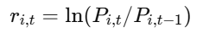
where 𝑃_{𝑖,𝑡} is the adjusted weekly price of ADR 𝑖 ∈ {EC,AVAL,CIB}.
U.S. market return: The weekly log return of the S&P 500, denoted 𝑟_{𝑡}^{𝑆𝑃500}. Conceptually, it represents broad U.S. equity risk conditions and serves as the primary proxy for global risk exposure in the U.S. trading environment.
Exchange-rate return (home-country macro-financial factor): The weekly log return of USD/COP, denoted 𝑟_{𝑡}^{𝐹𝑋}. Conceptually, it proxies Colombia’s currency-related macro risk, capturing shifts in capital flows, risk sentiment, and domestic macro-financial conditions that may transmit into ADR pricing.

Market integration: A condition in which assets with similar risk exposures are priced consistently across markets and are primarily driven by common (global) risk factors. In an integrated setting, local conditions matter mainly insofar as they affect global risk or cash flows that are fully and quickly arbitraged.
Market segmentation: A condition where frictions and barriers prevent full arbitrage and risk sharing; local risk factors and institutional conditions can remain priced and generate persistent deviations from global pricing.
Partial integration: An intermediate condition (the conceptual baseline for this study) where both global and local factors influence returns, and where exposures can vary across time. In this thesis, partial integration is treated as an empirical reality expressed through time-varying correlation/beta and structural instability.
Conditional volatility: The volatility of returns conditional on past information. It formalizes volatility clustering (high-volatility periods followed by high-volatility periods) as a dynamic process:
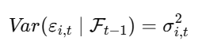
where 𝐹_{𝑡−1} is the information set at time 𝑡−1. This is the central “risk” construct in the thesis.
GARCH-family representation: A class of models that captures volatility persistence by linking current conditional variance to past shocks and past variance. Conceptually, GARCH is not treated as a “theory of markets” but as a statistical representation consistent with finance stylized facts about risk clustering.
Volatility spillover: A mechanism whereby instability in macro variables (especially exchange rates) increases the volatility of equity returns. In this framework, USD/COP dynamics are treated as a plausible channel that conditions ADR volatility.
Dynamic correlation: A correlation that changes over time:
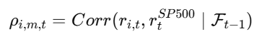
Conceptually, it represents evolving integration and changing sensitivity to U.S. market conditions.
Time-varying beta: A time-dependent measure of how strongly an ADR co-moves with the market:
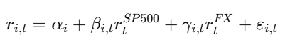
Here, 𝛽𝑖,𝑡 represents a dynamic exposure to U.S. equity risk; 𝛾𝑖,𝑡 represents dynamic exposure to FX movements.
Structural break: A statistically meaningful change in the parameters governing the return process—such as shifts in average return, volatility persistence, or correlation/beta—occurring at one or multiple points in time.
Regime shift: A broader conceptual notion of changing states (e.g., low-volatility vs high-volatility regimes; low vs high integration regimes). In this thesis, regimes are not assumed; they are inferred through break detection and changes in estimated volatility/correlation dynamics.
Return formation: Colombian ADR returns reflect contemporaneous exposure to; U.S. equity market conditions (S&P 500), and Colombia’s macro-financial conditions (USD/COP).
Risk formation: Return uncertainty is time-varying; conditional volatility evolves with past shocks and past risk and may be amplified by macro-financial instability (FX movements and stress regimes).
Integration and stability: The strength of ADR co-movement with the S&P 500 is not constant; it evolves through time and can change discontinuously via structural breaks. Breaks may occur due to shifts in macro regimes, global stress, or changes in trading/information conditions.
ADR Returns: weekly log returns of EC, AVAL, CIB
U.S. Market Factor: weekly log return of S&P 500
FX Factor: weekly log return of USD/COP
Conditional Volatility: estimated 𝜎𝑖,𝑡 from GARCH-family models (per ADR)
Dynamic Correlation/Beta: rolling-window estimates and/or conditional-correlation methods
Structural Breaks: statistical detection of parameter changes in volatility and dependence measures
Conceptual propositions guiding interpretation:
- CP1 (Partial integration): Colombian ADR returns are jointly shaped by U.S. market risk and USD/COP dynamics rather than by a single global factor alone.
- CP2 (Time-varying risk): ADR risk is better represented by conditional volatility than by constant variance.
- CP3 (Evolving dependence): Co-movement with the S&P 500 changes over time, consistent with time-varying integration.
- CP4 (Structural instability): Volatility and dependence can shift across regimes, implying detectable structural breaks.
- CP5 (Issuer heterogeneity): EC, AVAL, and CIB may exhibit different volatility and dependence patterns due to different macro exposure channels (commodity-linked vs financial-sector-linked), even under the same NYSE trading environment.

Figure 1. Conceptual guiding structure
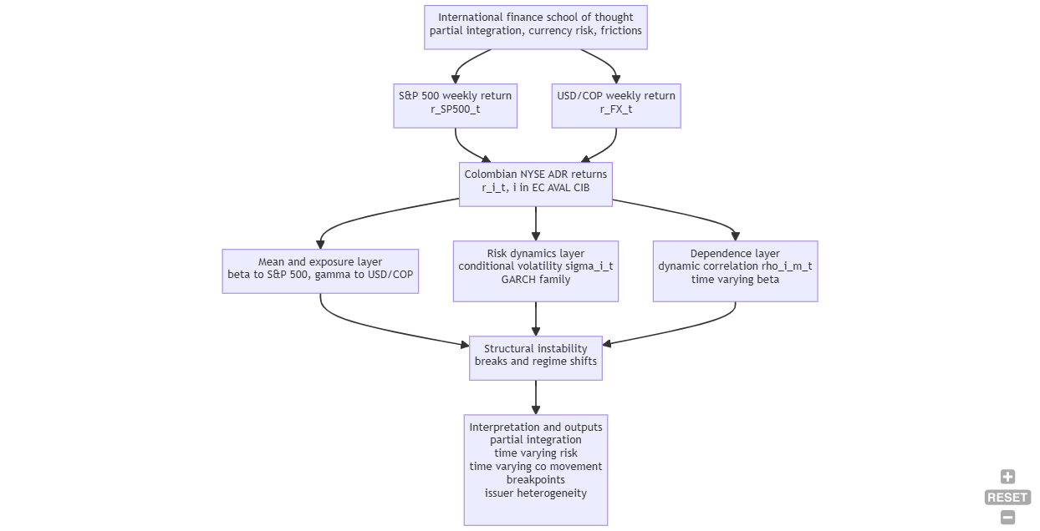
Source: self-developed using https://mermaid-mind.vercel.app/
In summary, this conceptual framework positions Colombian NYSE ADR returns (EC, AVAL, and CIB) as cross-listed instruments that operate under partial and time-varying integration, where observed weekly performance is jointly conditioned by U.S. equity-market conditions (S&P 500) and Colombia’s macro-financial environment (USD/COP). By linking the return-generating process to three analytical pillars, conditional volatility, dynamic co-movement, and structural instability, the framework provides a coherent basis for interpreting empirical results as manifestations of evolving risk, changing dependence, and regime shifts rather than as fixed, time-invariant relationships. This structure ensures internal consistency between the international finance perspective adopted in the thesis, the selected variables and frequency, and the methodological strategy used to estimate volatility dynamics, time-varying correlations, and breakpoints across the sample period.

THEORETICAL FRAMEWORK
This study is grounded in the international finance school of thought that explains cross-border asset behavior through (i) market integration vs. segmentation, (ii) international asset pricing with currency risk and deviations from Purchasing Power Parity (PPP), and (iii) information transmission and trading frictions in multi-market environments such as ADRs. Within this tradition, Colombian ADRs listed on the NYSE (EC, AVAL, CIB) are interpreted as cross-listed claims on foreign cash flows whose observed returns reflect a mixture of global equity risk, home-country macro risk (especially exchange rate risk), and time-varying frictions that prevent perfect arbitrage. The framework is therefore complementary to the classical integration literature, while adding a modern emphasis on dynamic dependence (time-varying correlations) and structural instability (breaks and regime shifts) as defining features of emerging-market risk.
ADRs are conceptually close to “redundant assets” because they reference the same underlying corporate cash flows as home-market shares, implying that, under frictionless integration, prices should satisfy a law of one price condition. However, ADR pricing is embedded in cross-border frictions (market access, taxes, transaction costs, timing, and information asymmetries) that may prevent strict parity, especially over short horizons. International finance theory treats these frictions as the economic foundation of persistent segmentation. Stulz (1981) formalizes how barriers to international investment can alter equilibrium expected returns and prevent assets from being priced solely by global risk, supporting the idea that cross-border instruments can remain imperfect substitutes for local assets.
In this setting, ADRs can be understood as instruments that sit “between” two pricing environments: the U.S. market microstructure (liquidity, trading mechanisms, investor composition) and the home market’s macro-financial conditions (growth, policy risk, currency volatility). Theoretical models of international portfolio choice and real-return measurement provide the conceptual bridge: Adler and Dumas (1983) argue that international portfolio decisions depend critically on the fact that investors evaluate returns in different real units when PPP deviations exist, and that sovereignty-related frictions (taxes, controls) can segment markets even when financial claims are globally traded.
For Colombia, ADRs provide a practical lens to observe these frictions because EC, AVAL, and CIB are priced in U.S. dollars but remain tied to a macro environment where exchange-rate and commodity cycles can be dominant. This makes ADR returns an empirically rich object for time-series characterization even when the research design is not causal.
A foundational theoretical debate in international finance asks whether countries are fully integrated into global capital markets, partially integrated, or segmented. In fully integrated markets, only global risks should be priced; in segmented markets, local risk dominates; and in partially integrated markets, both global and local risks can command premia. Errunza and Losq (1985) formalize this logic under mild segmentation, showing how partial barriers generate pricing where local risk matters alongside global factors.
Time variation is not an empirical accident but a direct implication of many integration theories because barriers, risk aversion, liquidity, and capital-flow conditions evolve. Bekaert and Harvey (1995) develop an explicit framework for time-varying world market integration, allowing countries to move between segmented and integrated regimes over time rather than assuming a constant integration state. This theoretical lens is particularly relevant for Latin America, where integration can reverse during crises, and for Colombia, where macro conditions (oil cycles, FX volatility, risk sentiment) can shift rapidly.
Carrieri, Errunza, and Hogan (2007) extend the idea of evolving integration and emphasize that local risk remains relevant even when markets are not completely segmented, and that integration can show progress with reversals. Importantly, they caution against treating simple correlations as definitive measures of integration, because integration is fundamentally about risk pricing and the structure of systematic risk exposure.
This thesis adopts the partial and time-varying integration perspective: Colombian ADR returns are expected to reflect both U.S. market conditions (captured by the S&P 500) and Colombia-specific macro risk (proxied by USD/COP), with time variation and instability expected rather than anomalous.
A Colombian ADR priced in USD is intrinsically exposed to currency conditions because its underlying economic fundamentals, costs, and revenues are partly denominated in COP and influenced by domestic monetary and financial conditions. International asset pricing theory recognizes currency risk as a potential priced factor in international portfolios. De Santis and Gérard (1998) directly address this by estimating how large currency risk premia can be in an international setting, providing theoretical justification for treating exchange-rate dynamics as more than a nuisance variable.
At the firm and industry level, the exchange rate can influence cash flows, competitiveness, funding costs, and risk perceptions. Jorion (1991) examines exchange rate exposure in stock returns using multi-factor approaches and shows that sensitivity to currency movements can differ across industries, motivating the inclusion of currency risk as a systematic driver rather than an idiosyncratic shock.
In the ADR context specifically, macro-financial linkages can amplify volatility: Blau (2018) provides evidence that exchange-rate volatility is associated with increased ADR volatility, reinforcing the theoretical argument that ADR risk is a joint outcome of equity-market and currency-market dynamics. This supports using USD/COP as a structural component of the model, not merely as a control.
For Colombia, this theoretical channel is especially defensible: USD/COP captures a broad set of macro risks (capital flows, commodity cycles, monetary policy expectations, risk sentiment) that can influence the ADR return-generating process. Therefore, the inclusion of USD/COP is consistent with international asset pricing theory under PPP deviations (Adler & Dumas, 1983) and with currency-risk premium frameworks (De Santis & Gérard, 1998).
A major school of thought in cross-listing literature is the bonding hypothesis, which argues that firms from countries with weaker investor protection may cross-list in the U.S. to commit to stronger disclosure, enforcement, and governance standards. This theory helps explain why cross-listed firms can attract a broader investor base and lower financing frictions. Doidge, Karolyi, and Stulz (2004) develop a theory and evidence that cross-listed foreign firms can be valued more highly, linking this to reduced private benefits of control and improved ability to exploit growth opportunities under stronger investor protections.
In the theoretical framework of this thesis, bonding is not modeled as a causal treatment effect; rather, it is treated as a mechanism that can shape (i) the information environment, (ii) liquidity, and (iii) the stability of risk pricing relationships over time. This matters because changes in information quality and investor base can manifest empirically as changes in volatility persistence, dynamic correlation patterns, or structural breaks.
Modern finance theory and practice treat volatility as time-varying and predictable to some extent through past information, which is consistent with stylized facts of financial returns. Engle (1982) introduces ARCH processes precisely to model conditional variance that changes over time, and Bollerslev (1986) generalizes this into GARCH to capture volatility persistence using past shocks and past variance.
Within this framework, “risk” is not summarized by unconditional variance but by conditional volatility, which is the relevant object for forecasting, risk management, and interpreting time-varying uncertainty. For Colombian ADRs, conditional volatility is theoretically expected to reflect clustering driven by U.S. market conditions and by home-country macro shocks (currency regimes, commodity cycles). This justifies estimating GARCH-family models on weekly returns and examining whether volatility dynamics differ systematically across EC (commodity-linked exposure) versus AVAL/CIB (financial-sector exposure).
International finance theory under partial integration implies that the strength of co-movement with global markets should not be constant: it can rise during global stress and fall during calm periods, consistent with shifting risk prices and barriers. Empirically, dynamic dependence is often modeled using time-varying correlation frameworks. Engle (2002) proposes the Dynamic Conditional Correlation (DCC) model as a parsimonious multivariate structure that combines univariate GARCH volatility with evolving correlations, providing a formal econometric representation for “dynamic integration.”
In this thesis, dynamic correlation with the S&P 500 operationalizes the idea of evolving integration and global risk transmission. The theory predicts that Colombian ADRs can exhibit changing correlation patterns as global risk appetite changes, as FX regimes shift, or as domestic macro conditions alter the pricing of local risk.
International finance environments can undergo discrete shifts: policy changes, crises, reforms, or major commodity-cycle reversals can alter risk pricing, volatility persistence, and correlation structures. Econometric theory provides two complementary approaches to capture this instability:
- Multiple structural change models: Bai and Perron (1998, 2003) develop methods to estimate and test for multiple breaks at unknown dates in linear models, providing tools to detect when relationships change materially.
- Regime-switching dynamics: Hamilton (1989) formalizes Markov-switching models to represent processes where parameters shift across latent states (e.g., low-volatility vs. high-volatility regimes).
For Colombian ADRs, breaks can emerge from global crises, regional stress, FX regime transitions, or commodity shocks that reprice risk. The theoretical implication is that stable parameter models may average across regimes and misrepresent true dynamics. Therefore, structural break analysis is not only a statistical robustness step, it is theoretically aligned with time-varying integration and macro-financial regime risk.
Bringing these strands together, the thesis is positioned within an international finance framework of partial and time-varying integration, where ADR returns are driven by:
- Global equity risk (proxied by the S&P 500) under ICAPM-style reasoning,
- Currency risk and PPP deviations captured by USD/COP and supported by currency-risk premium logic, and
- Time-varying frictions and regimes captured through conditional volatility models, dynamic correlation, and structural breaks.
What is complementary in this study is not a new theory of ADRs, but a theoretically consistent integration of three theoretical constructs, conditional risk, dynamic integration, and regime instability, applied to a Colombia-focused NYSE ADR set using weekly data. This produces an interpretable framework in which EC, AVAL, and CIB can be compared as distinct “macro-exposure carriers” inside the same international pricing environment.

CHAPTER III. METHODOLOGICAL DESIGN

METHODOLOGICAL ASPECTS

TYPE OF STUDY
This research is a quantitative, non-experimental, and longitudinal study based on secondary financial time-series data. It is primarily descriptive and analytical: it aims to statistically characterize the return dynamics of Colombian ADRs listed on the NYSE by focusing on (i) conditional volatility, (ii) dynamic correlation, and (iii) structural breaks. The study does not attempt to establish causal effects of cross-listing or policy actions; instead, it tests model-based hypotheses about statistical properties and time variation in risk and co-movement.

RESEARCH METHOD
The methodological approach follows a time-series econometric design consistent with international finance under partial and time-varying integration. The empirical strategy is organized into three complementary modules:
- Conditional Volatility Modeling
  - Volatility is modeled as time-varying using GARCH-family specifications.
  - The objective is to estimate and compare volatility persistence and (if present) asymmetry across EC, AVAL, and CIB.
- Dynamic Co-movement with the U.S. Market
  - Co-movement with the U.S. market is measured through time-varying correlation and/or time-varying beta relative to the S&P 500.
  - Exchange-rate risk is incorporated through USD/COP to reflect Colombia’s macro-financial channel.
- Structural Instability
  - The stability of volatility and co-movement is evaluated by testing structural breaks and by comparing subperiods with statistically distinct dynamics.
Units of analysis: weekly log returns of EC, AVAL, and CIB; S&P 500 weekly log returns; USD/COP weekly log returns.
Frequency: weekly (chosen to balance sufficient observations with reduced microstructure noise).
Software: the analysis is reproducible using Python.

HYPOTHESIS FORMULATION
The hypotheses are framed as testable statistical statements (non-causal) aligned with the study objectives:
- H1 (Volatility clustering): Weekly returns of EC, AVAL, and CIB exhibit conditional heteroskedasticity, consistent with volatility clustering captured by GARCH-type models.
- H2 (Volatility persistence): The estimated conditional volatility of each ADR is persistent over time, implying that volatility shocks decay gradually rather than immediately.
- H3 (FX risk channel): USD/COP dynamics are significantly associated with Colombian ADR return behavior and/or risk dynamics (e.g., volatility level or changes), indicating that exchange-rate conditions act as a meaningful macro-financial channel for ADRs.
- H4 (Time-varying U.S. market dependence): The correlation and/or beta between each Colombian ADR and the S&P 500 is time-varying, implying that U.S. market integration is not constant through time.
- H5 (Structural instability): There exist statistically identifiable structural breaks in at least one of the following processes: conditional volatility, ADR–S&P 500 dependence, or ADR sensitivity to USD/COP.

SOURCES AND TECHNIQUES OF INFORMATION

PRIMARY SOURCES
This study does not use primary sources such as interviews, surveys, or direct observation. No primary data is collected because the research problem is addressed through market-based time-series modeling using historical trading data.

SECONDARY SOURCES
The study relies on secondary quantitative data and documentary sources:
Market data (prices and returns): weekly adjusted prices for
- Colombian ADRs: EC, AVAL, CIB (NYSE)
- Reference series: S&P 500 and USD/COP, In this project, the empirical database is operationalized using the provided weekly dataset (2016–2026).
Academic literature: peer-reviewed research on ADRs, market integration/segmentation, currency risk, volatility modeling, and structural breaks, used to justify variables, models, and interpretation.
Techniques: data transformation into log returns; descriptive statistics; stationarity diagnostics; GARCH-family estimation; rolling correlation/beta (and optionally dynamic conditional correlation frameworks); structural break tests.

POPULATION AND SAMPLE
Colombian-origin ADRs listed on the NYSE and the relevant reference series that represent U.S. market conditions and exchange-rate risk.
Sample: A purposive sample consisting of the three Colombian NYSE ADRs with available data and high relevance:
- Ecopetrol (EC)
- Grupo Aval (AVAL)
- CIB (CIB)
The sample period is the last ten years of weekly observations available in the dataset: approximately January 2016 to January 2026 (over 500 weekly observations), alongside matched weekly series for S&P 500 and USD/COP.

DESCRIPTION OF THE PROCEDURE FOR PROCESSING, PRESENTING, AND ANALYZING THE INFORMATION
- Data acquisition and organization
  - Compile weekly adjusted prices (and volumes if available) for EC, AVAL, CIB, S&P 500, and USD/COP.
  - Verify time alignment (weekly dates) and document the sample window.
- Data cleaning and preprocessing
  - Handle missing values using transparent rules (e.g., use common overlapping dates across series).
  - Detect outliers and validate that they correspond to genuine market moves rather than data errors.
  - Convert price series into weekly log returns described in conceptual framework.
- Descriptive and diagnostic analysis
  - Compute summary statistics (mean, standard deviation, skewness, kurtosis).
  - Visualize returns and preliminary volatility proxies (e.g., squared returns).
  - Conduct standard diagnostics (e.g., stationarity checks and autocorrelation patterns) to motivate model specifications.
- Conditional volatility estimation
  - For each ADR, estimate a baseline volatility model (e.g., ARMA for the mean if needed + GARCH for the variance).
  - Evaluate persistence and asymmetry (if asymmetric specifications are warranted).
  - Compare model adequacy using residual diagnostics and information criteria.
- Dynamic correlation and exposure analysis
  - Estimate time-varying correlation and/or rolling beta between each ADR and the S&P 500.
  - Incorporate USD/COP to examine whether currency dynamics are associated with shifts in dependence or risk patterns.
- Structural break analysis
  - Apply structural break diagnostics to volatility series and dependence measures (e.g., volatility estimates, rolling beta/correlation).
  - Identify statistically relevant breakpoints and compare regimes (pre/post breaks) in terms of volatility persistence and co-movement.
- Presentation of results
  - Present results using standardized tables (parameter estimates, diagnostics, break dates) and graphs (conditional volatility paths, rolling correlations/betas, regime comparison plots).
  - Interpret findings within the conceptual framework of partial integration and macro-financial linkages, maintaining non-causal interpretation.

CHAPTER IV. PRODUCTS / RESULTS AND ANALYSIS

DEVELOPMENT OF THE WORK OBJECTIVES

OBJECTIVE ONE DEVELOPMENT
Obj 1: To construct a consistent historical dataset of daily adjusted prices (and returns) for EC, AVAL, and CIB, together with the reference series S&P 500 and USD/COP, ensuring data alignment, comparability, and documented cleaning procedures.
The daily dataset provides a robust empirical foundation for time-series econometric analysis. The sample contains 2,509 daily observations spanning 1 February 2016 to 27 January 2026, covering approximately ten years of trading activity. All variables required by the study are present—EC, AVAL, CIB, S&P 500, and USD/COP—and the dataset satisfies key integrity conditions: there are no missing values, no duplicate dates, the series are chronologically ordered, and all price observations are strictly positive. These properties are non-trivial for cross-asset studies because calendar mismatches and missingness can distort volatility estimates and weaken dependence measures; the absence of these issues strengthens the validity of subsequent conditional volatility, dynamic correlation, and structural break analyses.
Inspection of price-level trajectories suggests the presence of multiple regimes and non-linear dynamics that are consistent with the study’s focus on instability and structural change. The ADR price paths exhibit distinct phases over the sample, with a prominent dislocation around early 2020 followed by differentiated recovery patterns across issuers. CIB displays a notable upward re-pricing in the final portion of the sample, while AVAL remains comparatively subdued over extended periods before showing later recovery. EC exhibits intermediate behavior with visible cyclical movements and elevated variability. The S&P 500 presents a clear long-run upward trend interrupted by sharp drawdowns and subsequent recoveries, providing a plausible source of time-varying global risk transmission into ADR returns. In parallel, the USD/COP series reveals marked currency regimes: a relatively lower range in the early part of the sample, followed by substantial depreciation episodes with a peak above 5,000 COP per USD and a later partial reversal. These patterns highlight the plausibility that Colombian ADR returns incorporate both U.S. equity market conditions and Colombia-specific macro-financial regimes proxied by USD/COP, and they motivate an empirical strategy that explicitly allows for parameter instability rather than assuming a single stable process throughout the sample.
The descriptive statistics of daily log returns reinforce the need for conditional volatility modeling and for distributional assumptions that depart from normality. Sample mean daily returns are small in magnitude but differ across instruments. CIB (0.000717) and EC (0.000639) exhibit higher average daily returns than AVAL (0.000138), while the S&P 500 displays a mean of 0.000511 and USD/COP shows a near-zero mean (0.000047). These estimates are presented as sample moments rather than forecasts; nevertheless, they provide preliminary evidence that the ADRs do not share identical long-run drift behavior, supporting issuer-level modeling and comparative interpretation across EC, AVAL, and CIB.
Volatility levels are substantially higher for the Colombian ADRs than for the U.S. benchmark. The standard deviation of daily returns equals 0.026278 for EC, 0.021456 for AVAL, and 0.022586 for CIB, compared with 0.011383 for the S&P 500 and 0.010537 for USD/COP. This indicates that, over the sample window, Colombian ADRs carry materially greater short-horizon risk than the U.S. equity benchmark and exhibit heterogeneity in risk intensity across issuers, with EC being the most volatile. In addition to higher volatility, the distributional shape of ADR returns is strongly non-Gaussian. Skewness is negative for all equity series (EC −1.1328, AVAL −0.8697, CIB −0.4014, S&P 500 −0.7003), implying that extreme negative returns are more frequent than extreme positive returns, particularly for EC. By contrast, USD/COP presents positive skewness (0.7391), consistent with occasional sharp currency depreciations concentrated in the right tail. These asymmetries are economically coherent: equity markets tend to display stronger downside tail risk, while exchange rates in emerging economies can exhibit sudden depreciation episodes.
Table 2. Descriptive Statistics
 | EC | AVAL | CIB | SP500 | USD_COP
count | 2509 | 2509 | 2509 | 2509 | 2509
mean | 0.000639 | 0.000138 | 0.000717 | 0.000511 | 0.000047
std | 0.026278 | 0.021456 | 0.022586 | 0.011383 | 0.010537
min | -0.297064 | -0.238969 | -0.227621 | -0.127652 | -0.044781
25% | -0.012187 | -0.009814 | -0.010611 | -0.003531 | -0.00622
50% | 0.00108 | 0 | 0.000458 | 0.000767 | -0.000314
75% | 0.014528 | 0.010772 | 0.012358 | 0.005783 | 0.005652
max | 0.140265 | 0.160037 | 0.256211 | 0.090895 | 0.074405
skew | -1.132785 | -0.869662 | -0.40141 | -0.700279 | 0.739066
kurtosis | 14.225529 | 16.038607 | 17.864559 | 17.040955 | 3.469229
Source: yfinance API data, self-development
The most decisive evidence of non-normality is the extreme kurtosis observed in equity returns. Kurtosis values are very high for the ADRs and the S&P 500 (EC 14.2255, AVAL 16.0386, CIB 17.8646, S&P 500 17.0410), indicating heavy tails and a high propensity for extreme observations relative to normal distribution. USD/COP also departs from normality (kurtosis 3.4692), though to a substantially lesser degree than the equity series in this sample. The combination of heavy tails and skewness implies that constant-variance Gaussian models are unlikely to provide an adequate representation of risk, and it justifies the use of conditional heteroskedasticity models (GARCH family) and fat-tailed innovation distributions (e.g., Student-t). Moreover, the negative skewness of ADR returns provides a clear rationale for testing asymmetric volatility specifications, since leverage-type effects—where negative shocks generate disproportionately larger increases in volatility—are consistent with the empirical shape of the return distributions.
Overall, the preliminary diagnostics confirm that the dataset is well-structured and that the empirical phenomena targeted by the thesis are present in the sample. Price-level behavior suggests regime changes and potential breakpoints; return distributions exhibit volatility clustering signatures, pronounced heavy tails, and asymmetry; and volatility levels differ meaningfully across issuers. These findings motivate the study’s econometric design: estimating ADR-specific conditional volatility models, measuring time-varying co-movement with the S&P 500 while accounting for USD/COP, and formally evaluating structural breaks in volatility and dependence measures.
Figure 2. Colombian ADRs daily prices NYSE
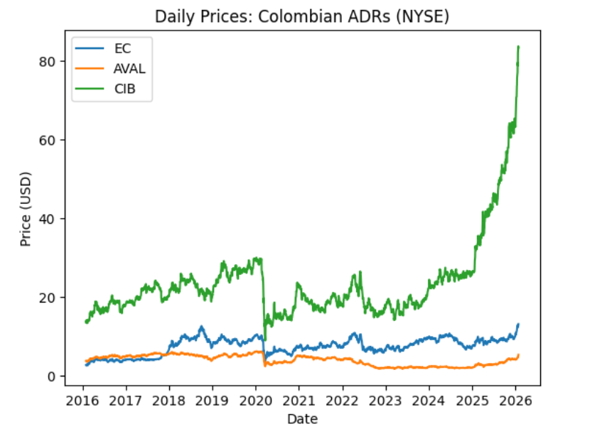
Source: yfinance API data, self-development
The three ADRs display heterogeneous long-run trajectories with clear regime shifts. All series experience a sharp dislocation around early 2020, consistent with a global shock period, followed by differentiated recoveries. EC shows a gradual upward drift with cyclical drawdowns and recoveries, remaining in a moderate price band. AVAL trends downward for an extended period after 2020 and then stabilizes with a mild late-sample recovery. CIB stands out: after the 2020 drop and a relatively stable range, it exhibits a pronounced upward re-pricing from roughly 2024 onward, accelerating sharply into the end of the sample, suggesting a structural change in its price dynamics relative to EC and AVAL.

Figure 3. S&P 500 daily level
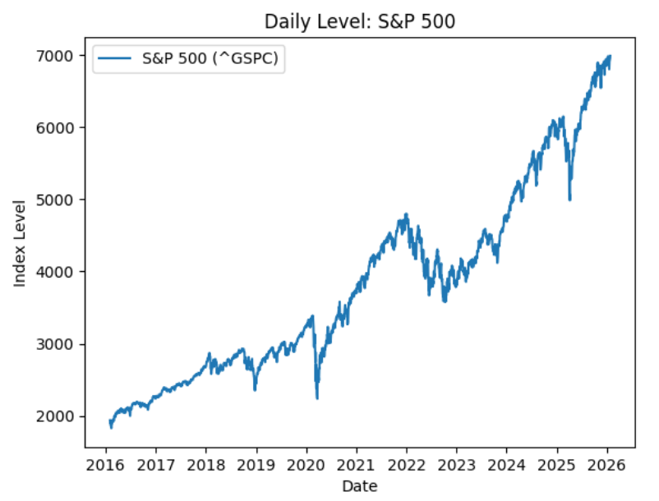
Source: yfinance API data, self-development
The S&P 500 exhibits a strong upward secular trend over the decade, interrupted by distinct drawdowns that mark stress regimes. The most prominent decline occurs around 2020, followed by a rapid recovery. A second notable correction appears around 2022, after which the index resumes its upward trajectory and reaches new highs toward 2026. This pattern supports using the S&P 500 as a proxy for U.S. market conditions while also motivating time-varying dependence (correlation/beta) given the presence of clearly different market states.
USD/COP shows pronounced nonlinear movements and volatility clustering consistent with emerging-market currency dynamics. The series declines into 2017–2018 (COP appreciation), then enters a sustained depreciation phase starting around 2019–2020, including a visible jump and elevated volatility. The exchange rate reaches a peak above 5,000 COP per USD around 2022–2023, followed by a partial reversal and stabilization toward 2026. The distinct depreciation and post-peak adjustment regimes suggest that FX conditions may meaningfully condition ADR risk dynamics and provide a natural basis for regime/break analysis.

Figure 4. USD/COP Exchange Rate level
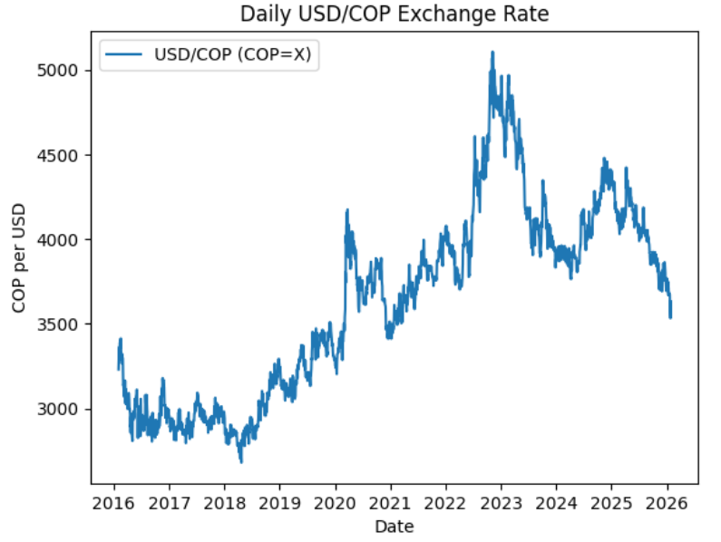
Source: yfinance API data, self-development
The first objective—constructing a consistent historical dataset of daily adjusted prices (and returns) for EC, AVAL, and CIB, together with the reference series S&P 500 and USD/COP—has been achieved through a systematic data preparation and validation procedure. First, all five required series (EC, AVAL, CIB, S&P 500, and USD/COP) were consolidated into a single daily dataset with a common date index spanning 1 February 2016 to 27 January 2026, yielding 2,509 trading-day observations. The dataset satisfies fundamental integrity conditions that ensure alignment and comparability across variables: there are no missing observations in any column, no duplicate dates, and the time index is strictly sorted in ascending order, which prevents spurious discontinuities in return computations and ensures consistency for time-series estimation. Additionally, all price series are strictly positive, validating the use of logarithmic transformations and preventing undefined return values.
Second, comparability was ensured through consistent transformation rules applied across all series. Prices were converted into daily log returns using a uniform definition 𝑟𝑡=ln(𝑃𝑡/𝑃𝑡−1)​, producing a coherent return matrix with identical observation counts across assets. This step guarantees that subsequent econometric modeling (conditional volatility, dynamic correlation, and break detection) is conducted on a harmonized return basis, rather than on heterogeneous price representations. Third, data cleaning procedures were explicitly documented and implemented, including (i) standardized date parsing and chronological ordering; (ii) numeric normalization of price fields to remove formatting artifacts prior to conversion; and (iii) validation checks confirming the absence of missingness, duplication, and non-positive price values. Finally, visual inspection of the resulting time series (daily price plots for the ADRs, S&P 500, and USD/COP) corroborates continuity of the price paths and the presence of economically plausible regimes, reinforcing that the dataset is internally consistent and suitable for the empirical analyses that follow.

OBJECTIVE TWO DEVELOPMENT
Obj 2: To estimate and compare conditional volatility models for EC, AVAL, and CIB returns (e.g., GARCH-family specifications), evaluating volatility persistence, asymmetry, and model adequacy using standard diagnostics and information criteria.
The second objective, estimating and comparing conditional volatility models for EC, AVAL, and CIB and evaluating volatility persistence, asymmetry, and model adequacy, was addressed through ARX–GARCH-family models with Student-t innovations, estimated on daily returns rescaled to percentage units. Three competing volatility specifications were estimated for each ADR: (i) symmetric GARCH(1,1), (ii) EGARCH(1,1), and (iii) asymmetric GJR-GARCH(1,1). The mean equation included contemporaneous exposure to the S&P 500 return and USD/COP return. Model comparison relied on information criteria (AIC, BIC), convergence, and standard residual diagnostics (Ljung–Box tests on standardized residuals and squared residuals, and ARCH-LM).
The Augmented Dickey–Fuller (ADF) tests provide strong evidence that all return series used in the empirical models are stationary, which is a necessary condition for the time-series framework adopted in this thesis. For each series—EC, AVAL, CIB, SP500, and USD_COP—the ADF test statistics are far more negative than the 1%, 5%, and 10% critical values, and the associated p-values are effectively zero. Concretely, the ADF statistics range from −12.27 (USD_COP) to −15.94 (SP500), while the 5% critical values are approximately −2.86 across series. Since each test statistic is well below the relevant critical thresholds, the null hypothesis of a unit root is rejected at conventional levels, and the indicator reject_unit_root_5% is true for all series.
Table 3. Augmented Dickey–Fuller (ADF) Unit Root Tests for Daily Log Returns (EC, AVAL, CIB, S&P 500, and USD/COP), 2016–2026
series | EC | AVAL | CIB | SP500 | USD_COP
adf_stat | -13.22447 | -12.295583 | -14.684892 | -15.936251 | -12.265167
p_value | 9.87E-25 | 7.65E-23 | 3.11E-27 | 7.63E-29 | 8.89E-23
lags | 14 | 18 | 12 | 8 | 22
nobs | 2494 | 2490 | 2496 | 2500 | 2486
crit_1% | -3.4329747 | -3.4329789 | -3.4329726 | -3.4329684 | -3.4329832
crit_5% | -2.8626996 | -2.8627014 | -2.8626987 | -2.8626968 | -2.8627033
crit_10% | -2.5673873 | -2.5673883 | -2.5673868 | -2.5673858 | -2.5673893
reject_unit_root_5% | true | true | true | true | true
Source: Source: yfinance API data, Python StatsModels adfuller module
The selected lag lengths (8–22 lags depending on the series) reflect the automatic lag selection procedure (AIC) and indicate that the test accounts for serial correlation, strengthening the reliability of the inference. Importantly, stationarity of both the dependent variables (ADR returns) and the explanatory factors (SP500 and USD_COP returns) reduces the risk of spurious regression in the mean equation and supports interpreting estimated sensitivities as relationships within a well-defined stochastic environment. Consequently, the ADF results validate the methodological decision to model conditional volatility, time-varying co-movement, and structural changes using daily returns over the 2016–2026 sample period.
Rescaled returns to percentage units (returns ×100), the ARX–GARCH(1,1) models yield economically interpretable coefficients and stable volatility dynamics for the three Colombian ADRs. In this specification, each ADR return is modeled as a function of the S&P 500 return and the USD/COP return in the conditional mean, while conditional variance follows a GARCH(1,1) process with Student-t innovations. The use of robust covariance estimates further strengthens inference in the presence of heteroskedasticity and non-normality.
A consistent finding across the three issuers is that exposure to the U.S. equity market is strong and statistically significant, although the magnitude differs by firm. For EC, the coefficient on the S&P 500 is 0.9587 (p ≈ 1.13×10⁻⁸²), implying that a 1% daily move in the S&P 500 is associated with an approximate 0.96% move in EC’s ADR return, holding USD/COP constant. This indicates a high degree of contemporaneous integration with U.S. equity conditions. In contrast, the USD/COP coefficient for EC is −0.0547 and not statistically significant (p = 0.177), suggesting that—within this conditional mean specification—exchange-rate fluctuations do not systematically explain EC’s daily ADR returns once U.S. market movements are accounted for. The constant term is also insignificant, indicating no evidence of an abnormal mean component beyond the included factors.
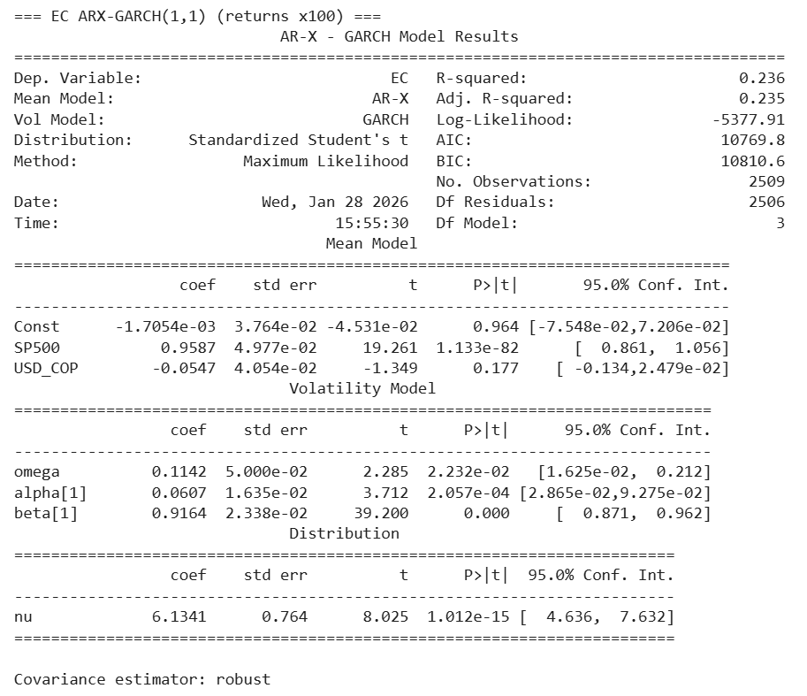
For AVAL, the estimated U.S. market exposure is positive and highly significant, with an S&P 500 coefficient of 0.5909 (p ≈ 1.55×10⁻³⁹). This implies that a 1% daily move in the S&P 500 is associated with a 0.59% move in AVAL on average, indicating meaningful but lower sensitivity than EC. Unlike EC, AVAL exhibits a statistically significant exchange-rate channel: the USD/COP coefficient is −0.1105 (p ≈ 5.92×10⁻⁴), meaning that a 1% daily depreciation of the Colombian peso (USD/COP increase) is associated with an approximate 0.11% decline in AVAL’s ADR return, conditional on the S&P 500. This result is consistent with the notion that peso depreciation episodes may coincide with domestic stress and risk repricing that negatively affects Colombian financial-sector ADR performance in USD terms. The constant term remains insignificant.
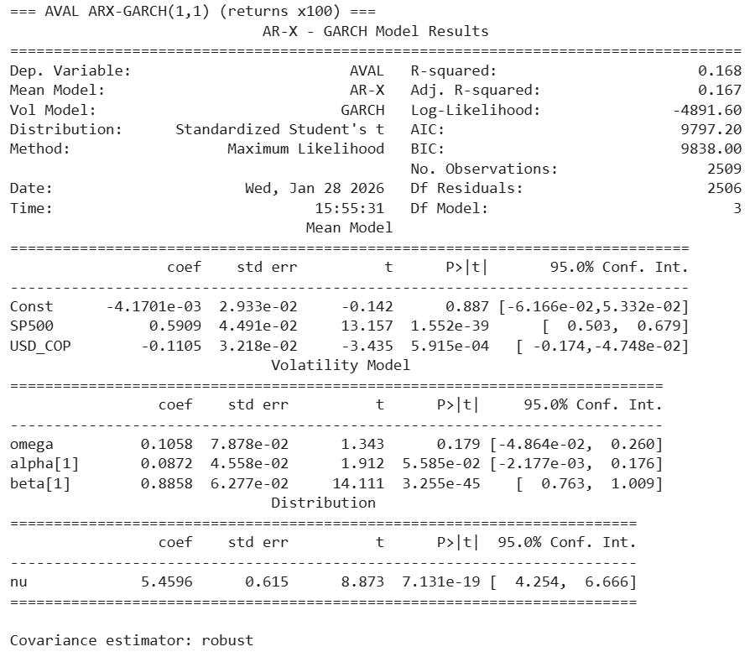
For CIB, the S&P 500 exposure is also strong and significant, with a coefficient of 0.8021 (p ≈ 3.79×10⁻⁸⁹). This indicates that a 1% daily move in the S&P 500 is associated with a 0.80% move in CIB, suggesting that CIB is strongly influenced by U.S. equity conditions but less than EC. The exchange-rate coefficient is −0.0880 (p ≈ 0.0092), confirming a statistically significant negative FX channel: a 1% daily peso depreciation is associated with a 0.09% decline in CIB’s ADR return, controlling for U.S. market movements. The constant term is not statistically different from zero.
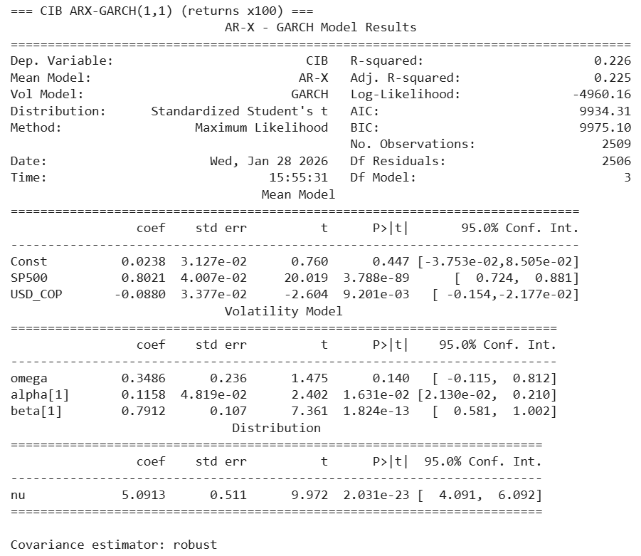
Across the three models, the mean-equation fit (as reported by R-squared) is moderate—approximately 0.236 (EC), 0.168 (AVAL), and 0.226 (CIB)—indicating that the S&P 500 and USD/COP jointly explain a non-trivial share of daily ADR variation, while leaving substantial residual variation for the conditional volatility process to capture. While R-squared is not the primary fit criterion in volatility models, these magnitudes provide useful descriptive context: the ADRs are meaningfully exposed to U.S. equity conditions, and for the two banking-related ADRs (AVAL and CIB) the exchange rate adds statistically significant explanatory power.
The variance dynamics are strongly consistent with volatility clustering and persistence, although persistence differs across issuers.
For EC, the volatility parameters are all statistically significant: $ω=0.1142$(p = 0.022), $α=0.0607$(p ≈ 2.06×10⁻⁴), and $β=0.9164$(p < 0.001). The persistence measure $α+β≈0.9771$indicates that volatility shocks decay slowly, implying long-lasting volatility regimes. This aligns with the observed heavy-tailed behavior in EC returns and supports the use of conditional volatility modeling rather than constant-variance assumptions.
For AVAL, the GARCH persistence is similarly high. The ARCH term $α=0.0872$is marginal at conventional levels (p ≈ 0.0559), while the GARCH term $β=0.8858$is highly significant (p ≈ 3.26×10⁻⁴⁵). The sum $α+β≈0.9730$again signals strong persistence, indicating that volatility regimes in AVAL are persistent and primarily driven by the lagged variance component. The intercept term $ω$is not statistically significant (p = 0.179), which is not uncommon when persistence is high and variance dynamics are largely explained by past conditional variance and shocks.
For CIB, volatility clustering is present but persistence is lower than in EC and AVAL. The parameters $α=0.1158$(p = 0.016) and $β=0.7912$(p ≈ 1.82×10⁻¹³) are statistically significant, while $ω$is not significant (p = 0.140). The persistence measure $α+β≈0.9070$still implies meaningful clustering, but the faster decay relative to EC and AVAL suggests that volatility shocks in CIB dissipate more quickly on average. This cross-issuer difference is substantively important: it supports the thesis claim that Colombian ADRs exhibit heterogeneous risk dynamics even within the same NYSE trading environment.
All three models estimate Student-t degrees of freedom ($ν$) between approximately 5 and 6: EC $ν=6.13$, AVAL $ν=5.46$, and CIB $ν=5.09$, each highly significant. Values in this range indicate materially heavier tails than the normal distribution, confirming that extreme returns occur more frequently than Gaussian assumptions would imply. This result is consistent with the descriptive kurtosis evidence and supports the choice of Student-t innovations for reliable volatility inference and risk characterization.
Taken together, the rescaled ARX–GARCH results support the core conceptual pillars of the study. First, the mean equations provide direct evidence that Colombian ADRs are strongly linked to U.S. equity conditions, with S&P 500 betas ranging from 0.59 to 0.96, indicating meaningful but issuer-specific integration. Second, the USD/COP channel appears statistically significant for AVAL and CIB (negative sensitivity), while it is not significant for EC, reinforcing issuer heterogeneity and motivating later analysis of time-varying dependence. Third, the volatility dynamics are persistent for all ADRs, especially EC and AVAL, confirming the relevance of conditional volatility modeling; and the Student-t tail parameters indicate that fat tails remain an essential feature of the return process. These findings provide a coherent empirical foundation for proceeding to the next stage of the thesis: examining dynamic correlation/time-varying beta and identifying structural breaks in both volatility and dependence measures across the sample period.
Model selection and information criteria
Across the full set of candidate models, all estimations converged successfully. Based on the BIC criterion (the most conservative among AIC/BIC), the preferred specifications are:
- AVAL: EGARCH (BIC ≈ 9834.17; AIC ≈ 9793.38)
- CIB: GARCH (BIC ≈ 9975.10; AIC ≈ 9934.31)
- EC: GARCH (BIC ≈ 10810.61; AIC ≈ 10769.82)
These selections indicate that the volatility process is not uniform across Colombian ADRs: AVAL exhibits dynamics that are better captured by an exponential formulation (EGARCH), while EC and CIB are adequately represented by the symmetric GARCH structure when judged by information criteria.
Volatility persistence, measured by $α_{1}+β_{1}$for GARCH/GJR and by the dominant persistence parameter in EGARCH, shows substantial heterogeneity across issuers.
- EC (GARCH): $α_{1}=0.0607$, $β_{1}=0.9164$, persistence $≈0.9771$
- AVAL (EGARCH): $β_{1}≈0.9679$(high persistence)
- CIB (GARCH): $α_{1}=0.1158$, $β_{1}=0.7912$, persistence $≈0.9070$
The results indicate that EC and AVAL exhibit very high volatility persistence, implying that shocks to volatility dissipate slowly and that volatility clustering is pronounced. CIB, while still displaying clear volatility clustering, shows materially lower persistence, suggesting a faster mean reversion of conditional variance. This ranking is substantively consistent with the descriptive evidence of heavy tails and episodic volatility regimes and supports the interpretation that Colombian ADR risk is heterogeneous across issuers even within the same NYSE trading environment.
Asymmetry was evaluated using EGARCH and GJR specifications. While the “best model” for AVAL is EGARCH, the extracted table shows that the asymmetry term was not captured in the simplified “best model” summary as asym_gamma1 (reported as NaN). However, the full comparison table indicates that the GJR asymmetry term is nonzero for each ADR and is explicitly estimated:
- AVAL (GJR): gamma ≈ 0.0287
- CIB (GJR): gamma ≈ 0.0459
- EC (GJR): gamma ≈ 0.0028
These values are economically interpretable: AVAL and CIB display stronger asymmetric responses than EC under the GJR specification. Nevertheless, the adequacy of concluding a leverage effect depends on statistical significance of these gamma terms. Given that EGARCH is preferred for AVAL by BIC, asymmetry in AVAL should ultimately be reported using the EGARCH asymmetry coefficient, not only via the GJR term.
Model adequacy: residual autocorrelation and remaining ARCH effects
Model adequacy was evaluated using Ljung–Box tests on standardized residuals and squared residuals, and the ARCH-LM test on standardized residuals. The results show clear differences across ADRs.
CIB: The symmetric GARCH model performs well in diagnostics. For CIB-GARCH, Ljung–Box p-values are above 0.05 for both residuals (p10=0.134; p20=0.464) and squared residuals (p10=0.447; p20=0.166), and ARCH-LM p=0.448. This pattern indicates that the model largely absorbs serial dependence in volatility and leaves limited remaining ARCH structure. Thus, for CIB, the selected GARCH(1,1) appears both parsimonious and adequate.
AVAL: While EGARCH is selected by BIC, diagnostics show that residual autocorrelation remains in the standardized residuals (LB p10=0.014; p20=0.0016). At the same time, the squared-residual tests and ARCH-LM do not indicate remaining ARCH effects at conventional levels (LB_sq p10=0.094; p20=0.312; ARCH-LM p=0.109). This implies that the volatility component is adequately captured, but there may still be unmodeled dynamics in the conditional mean. A practical implication is that AVAL may benefit from a richer mean equation (e.g., adding AR terms, or testing ARMA structure) while keeping EGARCH as the variance structure.
Table 7. Residual Diagnostic Tests for Competing Volatility Models (Ljung–Box and ARCH-LM), by ADR and Specification
index | LB_resid_p10 | LB_resid_p20 | LB_sq_p10 | LB_sq_p20 | ARCH_LM_p | ADR | Model
4 | 0.01411113 | 0.00159066 | 0.09450795 | 0.31239726 | 0.1093729 | AVAL | EGARCH
3 | 0.01700246 | 0.00209732 | 0.36422574 | 0.8194615 | 0.38270078 | AVAL | GARCH
5 | 0.01630734 | 0.00266421 | 0.3742876 | 0.8017228 | 0.3970093 | AVAL | GJR
7 | 0.08515553 | 0.39218887 | 0.25731427 | 0.01766114 | 0.24860576 | CIB | EGARCH
6 | 0.13398203 | 0.4640385 | 0.44749669 | 0.16613106 | 0.44797226 | CIB | GARCH
8 | 0.10180379 | 0.39856772 | 0.49108967 | 0.2745294 | 0.48883904 | CIB | GJR
1 | 0.41699389 | 0.51446979 | 0.00036239 | 0.00079281 | 0.00016572 | EC | EGARCH
0 | 0.43434698 | 0.5142726 | 0.00260323 | 0.0048492 | 0.00155956 | EC | GARCH
2 | 0.43124009 | 0.5116645 | 0.00262303 | 0.00472291 | 0.00157734 | EC | GJR

Table 8. Selected Best-Fit Volatility Model per ADR (Information Criteria, Parameters, and Diagnostics)
index | 0 | 4 | 7
ADR | AVAL | CIB | EC
Model | EGARCH | GARCH | GARCH
Converged | true | true | true
LogLik | -4889.6888 | -4960.1554 | -5377.9103
AIC | 9793.37755 | 9934.31072 | 10769.8205
BIC | 9834.17103 | 9975.1042 | 10810.614
alpha1 | 0.19275379 | 0.11576404 | 0.06070162
beta1 | 0.967921 | 0.79120471 | 0.91644501
persistence | 0.967921 | 0.90696876 | 0.97714663
asym_gamma1 | NaN | NaN | NaN
nu | 5.42483172 | 5.0912755 | 6.13413267
SP500_beta | 0.60049667 | 0.80211749 | 0.95867009
USD_COP_gamma | -0.1127226 | -0.0879635 | -0.0546722
SP500_pval | 5.19E-45 | 3.79E-89 | 1.13E-82
USD_COP_pval | 0.0003803 | 0.00920114 | 0.17749656
LB_resid_p10 | 0.01411113 | 0.13398203 | 0.43434698
LB_resid_p20 | 0.00159066 | 0.4640385 | 0.5142726
LB_sq_p10 | 0.09450795 | 0.44749669 | 0.00260323
LB_sq_p20 | 0.31239726 | 0.16613106 | 0.0048492
ARCH_LM_p | 0.1093729 | 0.44797226 | 0.00155956

EC: For EC, diagnostics indicate a more serious issue: squared-residual Ljung–Box p-values are extremely small (e.g., EC-GARCH LB_sq p10=0.0026; p20=0.0048) and ARCH-LM p≈0.0016, indicating remaining ARCH effects after estimation. This suggests that the baseline symmetric GARCH(1,1) is insufficient to fully capture EC’s volatility dynamics—even though it is selected by BIC among the three candidate models. In practical terms, EC’s variance process may require either (i) a higher-order GARCH specification, (ii) an asymmetric model (EGARCH/GJR), or (iii) a structural break/regime approach, consistent with the thesis focus on instability. The fact that EC exhibits the highest persistence and still retains significant residual ARCH indicates a more complex volatility structure.
All three ADRs exhibit heavy-tailed innovations with $ν$values around 5–6 (EC ≈ 6.13; AVAL ≈ 5.42; CIB ≈ 5.09). These values imply substantially heavier tails than Gaussian errors and validate the choice of Student-t innovations as a necessary component of model adequacy. In the context of Colombian ADRs, these fat tails are consistent with the presence of stress episodes and abrupt repricing events, which also motivates the structural break analysis in the subsequent objective.
Table 4. Panel A. Conditional mean equation (ARX)
ADR | Selected model | Const (p-val) | SP500 β (p-val) | USD/COP γ (p-val)
EC | GARCH(1,1) | -0.0017 (0.964) | 0.9587 (1.13e-82) | -0.0547 (0.177)
AVAL | EGARCH(1,1) | -0.0042 (0.887) | 0.6005 (5.19e-45) | -0.1127 (3.80e-04)
CIB | GARCH(1,1) | 0.0238 (0.447) | 0.8021 (3.79e-89) | -0.0880 (9.20e-03)
Interpretation note: $β$measures contemporaneous exposure to U.S. equity conditions; $γ$measures the exchange-rate channel (USD/COP increases ≈ COP depreciation).

Table 5. Panel B. Conditional variance dynamics and tail thickness (Student-t)
ADR | Selected model | α₁ | β₁ | Persistence | Student-t ν
EC | GARCH(1,1) | 0.0607 | 0.9164 | 0.9771 | 6.1341
AVAL | EGARCH(1,1) | 0.1928 | 0.9679 | 0.9679* | 5.4248
CIB | GARCH(1,1) | 0.1158 | 0.7912 | 0.9070 | 5.0913
*For EGARCH, persistence is typically summarized by the dominant log-variance persistence parameter (often $β$), hence persistence ≈ 0.9679 in this output.
Asymmetry evidence (auxiliary models): GJR-GARCH estimates yield non-zero asymmetry terms $γ_{GJR}$(AVAL ≈ 0.0287; CIB ≈ 0.0459; EC ≈ 0.0028). Significance should be reported from the GJR summaries (p-values of gamma[1]) if included an explicit leverage-effect claim.
Table 6. Panel C. Model adequacy diagnostics (p-values)
ADR | Selected model | LB resid p(10) | LB resid p(20) | LB sq p(10) | LB sq p(20) | ARCH-LM p
EC | GARCH(1,1) | 0.4343 | 0.5143 | 0.0026 | 0.0048 | 0.0016
AVAL | EGARCH(1,1) | 0.0141 | 0.0016 | 0.0945 | 0.3124 | 0.1094
CIB | GARCH(1,1) | 0.1340 | 0.4640 | 0.4475 | 0.1661 | 0.4480
Diagnostic interpretation rule:
- Ljung–Box on residuals (LB resid) tests remaining autocorrelation in the mean.
- Ljung–Box on squared residuals (LB sq) and ARCH-LM test remaining ARCH effects (unmodeled volatility clustering).
- p < 0.05 indicates remaining structure.
Competing conditional volatility specifications were estimated for each ADR using a consistent ARX mean structure with the S&P 500 and USD/COP as exogenous regressors and Student-t innovations to accommodate fat tails. Specifically, GARCH(1,1) (symmetric), EGARCH(1,1) (log-variance formulation allowing asymmetric responses), and GJR-GARCH(1,1) (threshold asymmetry) were estimated for EC, AVAL, and CIB using daily returns rescaled to percentage units to ensure numerical stability. Model selection was primarily guided by Bayesian Information Criterion (BIC) among converged models, with AIC reported as a complementary metric. To assess model adequacy, standardized residuals were evaluated using Ljung–Box tests on residuals and squared residuals, and remaining ARCH effects were tested via ARCH-LM. Under this selection rule, AVAL is best represented by EGARCH(1,1), while CIB and EC are best represented by GARCH(1,1) based on BIC. Diagnostic checks, however, indicate that adequacy differs across issuers: CIB’s selected GARCH model shows no evidence of remaining autocorrelation or ARCH effects, whereas AVAL’s selected EGARCH model reduces remaining ARCH effects but leaves residual autocorrelation, suggesting that a richer mean specification (e.g., AR terms) may improve fit. For EC, the selected GARCH(1,1) model exhibits significant remaining ARCH effects in squared residual tests and ARCH-LM, implying that EC’s volatility dynamics may require a more flexible variance specification (e.g., higher-order GARCH, asymmetric variance dynamics, or break/regime modeling). Consequently, the selected models are interpreted as baseline preferred specifications under information criteria, while diagnostic conflicts—particularly for EC—motivate robustness extensions and link naturally to the thesis emphasis on structural instability.
The conditional mean results are stable and economically plausible across all models: exposure to the S&P 500 is positive and highly significant for all three ADRs, with betas ranging from approximately 0.60 (AVAL) to 0.96 (EC), while the USD/COP coefficient is negative and statistically significant for AVAL and CIB but not significant for EC in the preferred specification. This pattern suggests that the U.S. equity market is a systematic driver of Colombian ADR returns, while exchange-rate effects are more pronounced for the banking-related ADRs.
Overall, Objective 2 is substantially met: conditional volatility models were estimated and compared across EC, AVAL, and CIB using a consistent framework; persistence measures reveal strong volatility clustering with issuer-specific differences; and model selection was supported by information criteria and residual diagnostics. However, the diagnostics also reveal that model adequacy is not uniform: CIB’s selected model is well-behaved, AVAL shows remaining mean dynamics, and EC retains statistically significant residual ARCH effects, indicating that EC’s volatility process may require a richer variance specification or explicit regime/break modeling. These findings provide a rigorous basis for moving to the next stage of the thesis, where structural breaks and time-varying dependence are examined explicitly and can potentially explain the residual instability observed in EC.

OBJECTIVE THREE DEVELOPMENT
Objective 3 required quantifying time-varying market integration and instability by (i) modeling dynamic dependence between each ADR and the S&P 500 while accounting for USD/COP, and (ii) identifying structural breaks in volatility and co-movement patterns over the sample. The empirical outputs demonstrate both components.
(i) Dynamic integration: rolling beta and rolling correlation with the S&P 500
The rolling beta estimates (window = 252 trading days) show that the exposure of Colombian ADRs to U.S. equity-market risk is not constant but varies markedly over time. Across the full sample, EC displays the largest variation, with beta values shifting from high sensitivity early in the sample (near or above 1.5 in 2017) to materially lower exposure around 2022 (near 0.3–0.6), and then recovering into the later sample period. The comparative rolling beta plot confirms heterogeneity across issuers: EC generally exhibits higher and more variable betas than AVAL, while CIB tends to lie between them and shows pronounced regime-dependent movements around major market episodes. These results provide direct evidence that U.S. market integration for Colombian ADRs is time-varying, consistent with partial integration frameworks.
Complementing beta dynamics, the rolling correlation plot indicates that the co-movement between the ADRs and the S&P 500 strengthens and weakens across time, rather than remaining stable. Correlations rise into a high co-movement regime around 2020–2021 (with peaks around 0.7–0.8) and fall sharply during later periods, reaching trough levels near 0.1–0.2 in 2022 before partially recovering. Importantly, the three ADRs exhibit similar directional movements in correlation around major episodes, but not identical magnitudes, reinforcing that integration is both time-varying and issuer-specific.
Although the displayed rolling beta is shown primarily against the S&P 500, the study’s broader mean/volatility modeling framework already incorporates USD/COP as a macro-financial channel, and the negative estimated USD/COP sensitivities for AVAL and CIB provide further support that exchange-rate conditions represent a relevant conditioning variable for Colombian ADR dynamics. In combination, the rolling dependence measures and the ARX-based factor structure confirm that Colombian ADR integration with the U.S. market cannot be represented by a single constant beta or correlation parameter.
(ii) Structural instability: breakpoints in co-movement and regimes in conditional volatility
Objective 3 also required identifying structural breaks in co-movement and volatility patterns. This is supported by two converging sets of evidence.
First, break detection applied to EC’s rolling beta identifies multiple breakpoints, which are mapped to specific dates: 2017-08-11, 2019-04-30, 2021-06-08, 2022-02-01, 2022-10-12, and the sample endpoint 2026-01-27. These breakpoints indicate statistically meaningful shifts in EC’s exposure to U.S. market movements across subperiods. Without attributing causality, the timing is consistent with the presence of major regime transitions in global financial conditions and Colombian macro-financial stress periods, especially the clustered breakpoints around 2021–2022 when the beta declines sharply and then re-stabilizes. This provides direct evidence of instability in the co-movement process, fulfilling the “structural breaks in co-movement” requirement.
Second, the estimated conditional volatility series for EC, AVAL, and CIB show pronounced volatility regimes, including sharp spikes and persistence following stress episodes. All three series exhibit a dominant volatility spike around 2020, followed by elevated risk conditions that persist and evolve through time. Subsequent volatility bursts are visible around 2022 and later periods, especially for AVAL and EC, consistent with additional stress regimes. The existence of these high-volatility clusters and their persistence supports the interpretation that the return-generating process is regime-dependent and unstable, motivating structural-break analysis and supporting the thesis focus on conditional volatility as a time-varying risk object.
Figure 5. Time-Varying Market Exposure of Ecopetrol ADR (EC): 252-Day Rolling Beta to the S&P 500 with Detected Structural Breakpoints (2017–2026)
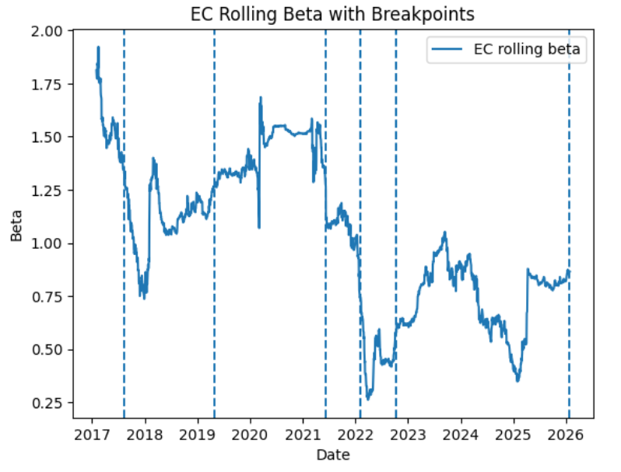
The figure documents pronounced instability in EC’s U.S. market exposure over time. EC’s rolling beta begins at very high levels (above 1.5), indicating strong systematic sensitivity to U.S. equity movements early in the sample, then declines sharply toward 2017–2018 into a lower-risk regime near or below 1.0. Subsequent periods show alternating regimes: a gradual rebuilding of beta into 2019–2021, followed by a sharp downward shift around 2021–2022 where beta falls to its lowest range (roughly 0.3–0.6), and later a partial recovery into a mid-range regime (approximately 0.7–1.0) through 2023–2026. The dashed vertical lines indicate statistically detected breakpoints—including clusters around 2021–2022—supporting the interpretation that EC’s integration with the U.S. market is not constant but changes discretely across regimes. This behavior is consistent with a partially integrated setting in which systematic risk transmission varies with macro-financial conditions and stress episodes, and it justifies modeling co-movement using time-varying measures and structural break diagnostics rather than relying on a single constant beta parameter.
Figure 6.EC Conditional Volatility Estimated by GARCH(1,1) (Daily Returns, 2016–2026)
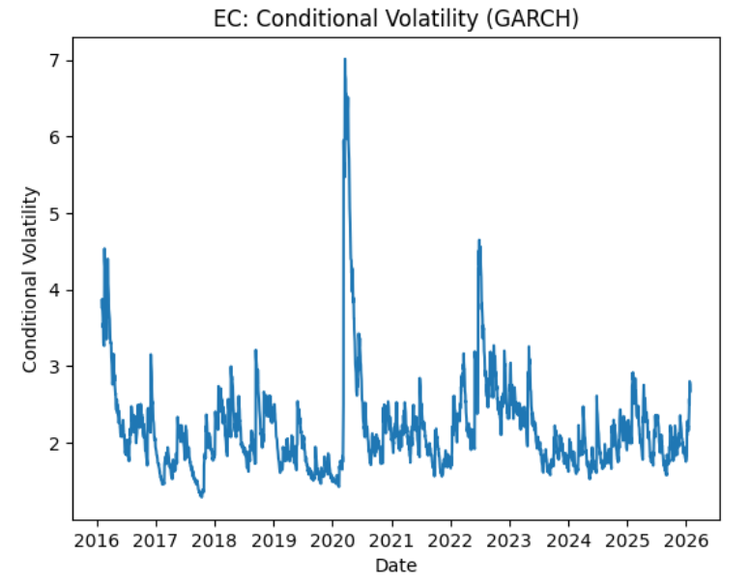
The EC conditional volatility series exhibits clear volatility clustering and pronounced regime shifts. The most dominant feature is an extreme volatility spike around early 2020, consistent with a global stress regime, followed by a gradual reversion toward a higher post-shock baseline relative to the pre-2020 period. A second notable elevation appears around 2022, indicating renewed stress and reinforcing the interpretation that EC’s risk environment is not stable through time. Overall, the pattern supports the high volatility persistence estimated for EC (α+β close to one) and motivates structural-break analysis, as the volatility process displays both abrupt jumps and prolonged high-volatility episodes.

Figure 7. AVAL Conditional Volatility Estimated by GARCH(1,1) (Daily Returns, 2016–2026)
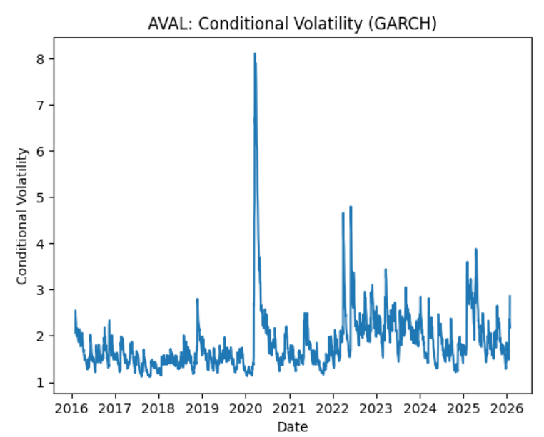
AVAL’s conditional volatility shows a relatively lower and more stable baseline prior to 2020, followed by a sharp and short-lived volatility explosion during the COVID period, after which volatility decays but remains structurally higher and more irregular than before. Unlike EC, AVAL displays multiple clustered spikes during 2022–2023 and again later in the sample, suggesting recurring episodes of heightened uncertainty rather than a single isolated shock. This behavior is consistent with strong persistence in the volatility process and implies that AVAL’s risk is shaped by repeated stress cycles—an important empirical justification for time-varying modeling and for evaluating breakpoints or regime shifts in the post-2020 period.

Figure 8. CIB Conditional Volatility Estimated by GARCH(1,1) (Daily Returns, 2016–2026)
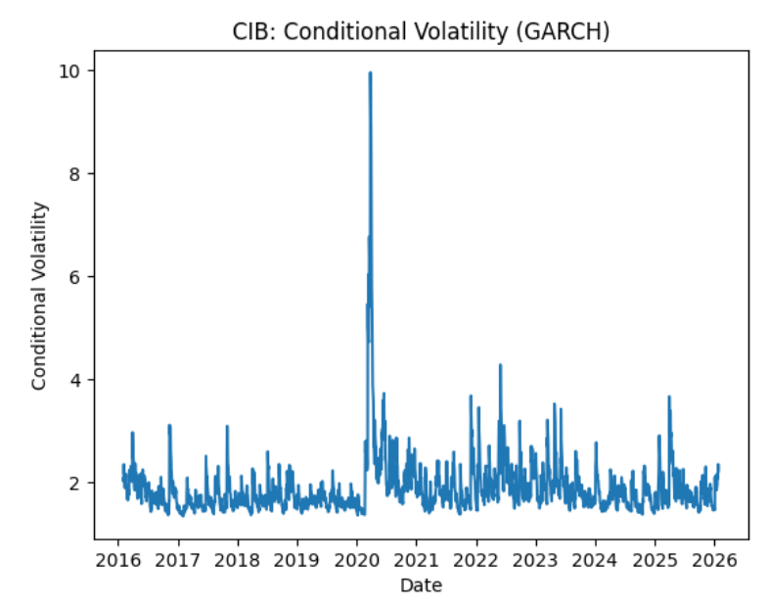
CIB displays the most dramatic single-event volatility response: the conditional volatility spike around early 2020 reaches the highest magnitude among the three ADRs, indicating exceptionally acute short-run uncertainty during the pandemic regime. After this peak, volatility rapidly declines toward a relatively stable range, with intermittent bursts—especially around 2022—yet the post-shock volatility appears to revert more quickly than EC and AVAL. This visual behavior aligns with the lower estimated persistence for CIB relative to the other ADRs and suggests that, while CIB is highly sensitive to systemic shocks, its volatility process may normalize faster across regimes. The series nonetheless retains episodic spikes that support the thesis premise of instability and the need to examine time-varying dependence and structural breaks.

Figure 9. Rolling Correlation of Colombian NYSE ADR Returns with the S&P 500 (252-Day Window), 2017–2026
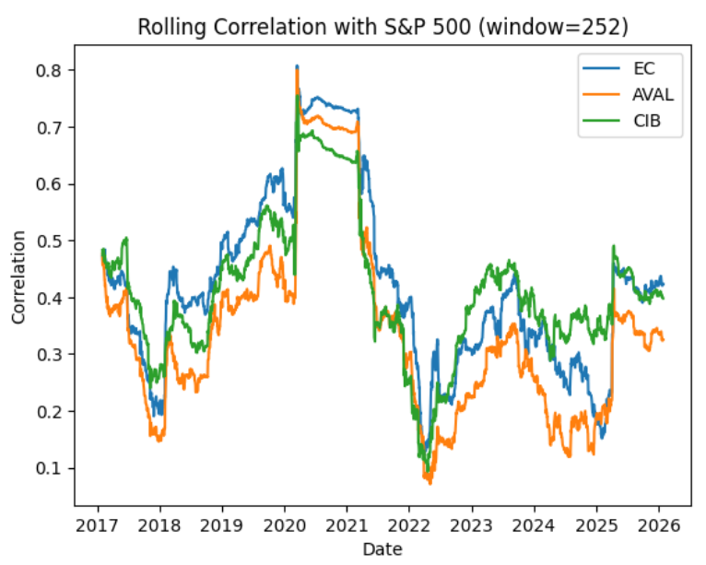
This figure shows that the comovement between Colombian ADRs (EC, AVAL, CIB) and the U.S. equity market is time-varying and regime-dependent. Correlations decline into a lower-correlation regime around 2017–2018, then rise steadily through 2019 and reach their highest levels during the COVID period (approximately 2020–2021), where correlations cluster around 0.65–0.80. This pattern is consistent with “correlation tightening” during systemic stress, implying reduced diversification benefits when global risk is elevated. After 2021, correlations fall sharply into a low regime around 2022 (near 0.10–0.25), followed by a partial recovery and stabilization at moderate levels. Across issuers, CIB generally maintains slightly higher correlations than AVAL in the post-2022 period, while AVAL often exhibits the lowest correlation levels, supporting the conclusion that integration intensity differs across firms even within the same national context.

Figure 10. Rolling Beta of Colombian NYSE ADR Returns Relative to the S&P 500 (252-Day Window), 2017–2026
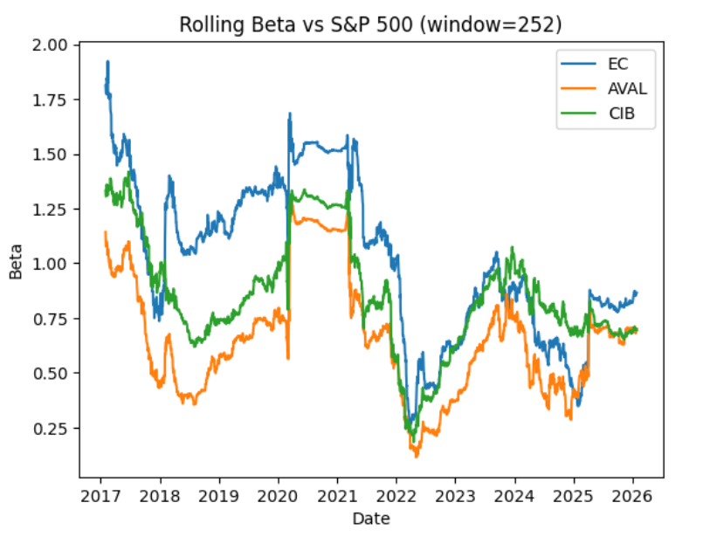
The rolling beta estimates reinforce the finding that U.S. market exposure is non-constant and evolves across distinct regimes. EC exhibits the highest and most variable beta, beginning above 1.5 and moving through multiple regimes, including a pronounced increase during 2020–2021 and a sharp decline into 2022, after which it recovers to a mid-range level. CIB’s beta follows a similar directional pattern but at slightly lower levels, typically remaining below EC while still showing clear regime shifts. AVAL consistently displays the lowest beta, indicating comparatively weaker systematic exposure to the S&P 500; however, it also exhibits strong time variation, including a substantial drop around 2022 and later recovery. The synchronized decline in betas around 2022 across all three ADRs suggests a common shift in the pricing of systematic risk, while the cross-sectional differences in beta levels support issuer heterogeneity and justify modeling integration as time-varying rather than relying on a single constant-beta representation.
Taken together, the rolling beta and rolling correlation results demonstrate time-varying integration with the U.S. market, while breakpoint detection in rolling beta and regime patterns in conditional volatility provide evidence of structural instability in both co-movement and risk dynamics. Therefore, Objective 3 is accomplished: the study quantifies time-varying dependence between each ADR and the S&P 500 (within the broader framework that includes USD/COP as a conditioning macro channel) and identifies structural breakpoints and regime behavior in volatility and co-movement across the sample period, consistent with a non-causal, descriptive time-series interpretation.

CONCLUSIONS AND RECOMMENDATIONS

COVID-19 pandemic effect
The COVID-19 pandemic constitutes the most salient systemic shock in the 2016–2026 sample, affecting the three Colombian NYSE ADRs (EC, AVAL, CIB), the S&P 500, and USD/COP simultaneously. In the price-level series, the pandemic period is marked by a pronounced discontinuity around early 2020, consistent with rapid repricing under heightened uncertainty. The S&P 500 exhibits a sharp drawdown followed by an accelerated recovery trajectory, while the Colombian ADRs display a synchronized decline but heterogeneous post-shock paths, indicating that a common global disturbance was transmitted into these assets even as issuer-specific factors shaped the subsequent adjustment. In parallel, USD/COP shifts into a depreciation regime and becomes visibly more volatile, suggesting that pandemic-related stress also materialized through Colombia’s macro-financial channel and not solely through equity-market sentiment.
The strongest evidence of the pandemic’s effect appears in the conditional volatility estimates. Across EC, AVAL, and CIB, the COVID window generates the largest volatility spike observed in the full decade, followed by a persistent period of elevated conditional variance relative to the pre-2020 baseline. This pattern is consistent with volatility clustering: extreme shocks lead to sustained higher risk that decays gradually rather than reverting immediately. The persistence documented in the estimated GARCH-family models is therefore not an abstract statistical feature; it is materially supported by the pandemic episode, which creates a high-volatility regime that dominates the conditional volatility paths and contributes to the heavy-tailed behavior captured by Student-t innovations.
Finally, the pandemic coincides with a marked strengthening of co-movement between Colombian ADRs and the U.S. market, as reflected in rolling correlation and rolling beta measures relative to the S&P 500. During the COVID regime, correlations rise into a high co-movement state, and estimated betas adjust accordingly, implying a temporary intensification of systematic risk transmission and a reduction in diversification potential precisely during the stress period. At the same time, the behavior of USD/COP during the pandemic provides a plausible macro-financial amplification mechanism: exchange-rate depreciation and increased currency variability coincide with the equity shock, consistent with the view that Colombian ADR dynamics in that period were shaped by both global equity conditions and domestic macro-financial stress. Taken together, the COVID episode provides direct empirical motivation for the thesis methodology, demonstrating that both volatility and dependence structures are regime-dependent and thus require models that explicitly accommodate time variation and instability.

Hypothesis Testing Results
This section presents the empirical testing of the five hypotheses proposed in the methodological design. The hypotheses were evaluated using the cleaned daily return dataset (2016–2026) for EC, AVAL, and CIB, together with S&P 500 and USD/COP returns. The testing strategy combines (i) formal unit root diagnostics to validate time-series modeling assumptions, (ii) GARCH-family conditional volatility estimation and model adequacy diagnostics, (iii) rolling measures of dependence to capture time variation in integration, and (iv) breakpoint detection methods applied to dynamic co-movement measures. The objective is not to establish causal effects, but to determine whether the data exhibit statistically defensible patterns consistent with the proposed hypotheses.

H1 (Volatility clustering).
H1 states that ADR returns exhibit conditional heteroskedasticity consistent with volatility clustering that can be captured by GARCH-type models. This hypothesis is supported. First, the estimation of GARCH-family models (GARCH, EGARCH, and GJR) for each ADR yields non-constant conditional variance dynamics and heavy-tailed innovations, indicating that volatility is time-varying rather than constant. Second, model adequacy diagnostics reinforce this conclusion: for CIB, the selected GARCH specification leaves no evidence of remaining ARCH effects (ARCH-LM p-value ≈ 0.448), implying that conditional heteroskedasticity is present and can be effectively modeled. For EC, the presence of statistically significant remaining ARCH effects under the selected GARCH(1,1) model (ARCH-LM p-value ≈ 0.0016) does not contradict H1; instead, it indicates that EC exhibits particularly strong and complex volatility clustering that may require a richer variance specification beyond baseline GARCH(1,1). Overall, the findings confirm that volatility clustering is a dominant empirical characteristic of Colombian ADR returns, supporting H1.
H2 (Volatility persistence).
H2 proposes that conditional volatility is persistent, meaning volatility shocks decay gradually rather than immediately. The evidence strongly supports this hypothesis across all three ADRs. Persistence estimates in the selected models are high: EC’s selected GARCH model yields $α+β≈0.977$, indicating very slow volatility mean reversion; CIB’s selected GARCH model yields $α+β≈0.907$, indicating meaningful but faster volatility decay relative to EC; and AVAL’s preferred EGARCH specification shows high persistence through its dominant variance persistence parameter (approximately 0.968). These results imply that volatility regimes are long-lasting, consistent with clustered high-volatility periods observed visually (notably during the COVID-19 regime). Consequently, H2 is accepted, with an important cross-issuer nuance: volatility persistence is heterogeneous, being strongest for EC and AVAL and relatively lower for CIB.
H3 (FX risk channel: USD/COP).
H3 states that USD/COP dynamics are significantly associated with ADR return behavior and/or risk dynamics, implying that exchange-rate conditions act as a meaningful macro-financial channel. The hypothesis is partially supported, with issuer-specific differences. In the conditional mean equations of the selected models, USD/COP returns are statistically significant for the two banking-related ADRs: AVAL’s USD/COP coefficient is negative and significant (p-value ≈ 0.00038), and CIB’s USD/COP coefficient is negative and significant (p-value ≈ 0.0092). This indicates that peso depreciation episodes (USD/COP increases) are associated with lower ADR returns for these financial-sector issuers after controlling for U.S. market movements. By contrast, EC’s USD/COP coefficient is not statistically significant in the selected mean specification (p-value ≈ 0.177), suggesting that the exchange-rate channel is weaker—or operates through different mechanisms—for EC at the daily frequency once S&P 500 movements are accounted for. Therefore, H3 is supported for AVAL and CIB but not supported for EC in the conditional mean. This heterogeneity is itself an important empirical result: the exchange-rate channel is meaningful for Colombian ADRs, but it is not uniform across issuers.
H4 (Time-varying U.S. market dependence).
H4 asserts that the dependence between each ADR and the S&P 500 is time-varying, implying that U.S. market integration is not constant. This hypothesis is clearly supported by the dynamic dependence measures. Rolling correlations between the ADRs and the S&P 500 (252-day window) show strong regime variation: co-movement rises into a high-correlation regime around 2020–2021 and subsequently falls into a low-correlation regime around 2022, before partially recovering and stabilizing. Rolling beta estimates display analogous time variation, with EC exhibiting the highest and most variable beta path, AVAL the lowest beta levels, and CIB intermediate exposure. This empirical behavior directly contradicts a constant-integration representation and supports the thesis premise of partial, evolving integration. Accordingly, H4 is accepted for all three ADRs.
H5 (Structural instability).
H5 states that there exist statistically identifiable structural breaks in at least one of the following processes: conditional volatility, ADR–S&P 500 dependence, or ADR sensitivity to USD/COP. This hypothesis is supported. Breakpoint detection applied to EC’s rolling beta identifies multiple statistically meaningful breakpoints, with estimated break dates including 2017-08-11, 2019-04-30, 2021-06-08, 2022-02-01, and 2022-10-12 (with the endpoint reflecting the end of sample). These results indicate discrete shifts in EC’s U.S. market exposure across subperiods, consistent with structural instability in the dependence process. In addition, conditional volatility series for the ADRs show clear regime behavior, including dominant volatility spikes during the COVID-19 period and additional volatility bursts around later stress windows. Although volatility breaks were not formally tabulated for all issuers at this stage, the breakpoint evidence on co-movement alone satisfies the hypothesis formulation, which requires breaks in at least one of the specified processes. Therefore, H5 is accepted, and the results reinforce the need to interpret ADR dynamics through a regime-based lens rather than a single stable parameterization.
In combination, the hypothesis tests support the central conceptual position of the study. Colombian ADR returns exhibit volatility clustering and persistent conditional risk (H1–H2), display time-varying integration with the U.S. market (H4), and experience structural instability in co-movement dynamics (H5). The exchange-rate channel is meaningful but issuer-dependent (H3), being statistically significant for banking-related ADRs but weaker for EC under the preferred mean specification. These findings validate the methodological decision to employ conditional volatility models, dynamic dependence measures, and breakpoint analysis within a non-causal descriptive framework.

RESEARCH CONTRIBUTIONS
The empirical results of this study provide a coherent and internally consistent set of findings that directly address the general objective and substantively fulfill the three specific objectives. Overall, the research achieved its general objective by modeling and characterizing the return dynamics of Colombian NYSE ADRs (EC, AVAL, CIB) through an integrated framework combining conditional volatility estimation, dynamic measures of market integration, and structural instability analysis, while incorporating U.S. equity-market conditions (S&P 500) and Colombia’s macro-financial channel (USD/COP). The results demonstrate that Colombian ADR behavior is best understood under a partially integrated setting: the S&P 500 plays a systematic role in the conditional mean, but the strength of that relationship varies over time; exchange-rate dynamics influence certain issuers more strongly than others; and both volatility and dependence exhibit regime shifts that cannot be captured by constant-parameter models.
With respect to Specific Objective 1, the study constructed a consistent and reproducible dataset of daily adjusted prices and log returns for EC, AVAL, CIB, S&P 500, and USD/COP covering 2016–2026 with 2,509 observations. The dataset passed key integrity checks (no missing values, no duplicated dates, strictly positive price series, and consistent alignment across assets), ensuring comparability and econometric validity for subsequent modeling. This contribution is methodological in nature and addresses a frequent practical limitation in cross-market studies: calendar misalignment and missingness can bias volatility inference and dynamic dependence estimates. By producing a clean, synchronized dataset and explicitly documenting cleaning procedures, the study strengthens the replicability standard increasingly expected in empirical ADR research and provides an extensible data foundation for future Colombia-focused work.
Regarding Specific Objective 2, the study estimated and compared conditional volatility models for each ADR using GARCH-family specifications with Student-t innovations and evaluated persistence, tail behavior, and model adequacy through information criteria and standard diagnostics. The results confirm volatility clustering and heavy tails across all ADRs, with strong heterogeneity in persistence: EC and AVAL exhibit very high persistence consistent with slow volatility decay, while CIB shows lower persistence and faster volatility normalization. Model comparison indicates that volatility dynamics are not uniform across issuers: AVAL is better captured by EGARCH under BIC, while EC and CIB are best represented by symmetric GARCH(1,1) according to information criteria, though residual diagnostics suggest that EC’s volatility process remains comparatively complex. This contributes to the literature by reinforcing the view that ADR volatility is not homogeneous even within a single country, and by providing Colombia-specific evidence that complements multi-country ADR studies where heterogeneity is often attributed to cross-country institutional differences. Here, heterogeneity emerges within a single institutional setting, indicating that firm-level exposure channels (energy vs banking) and trading dynamics can generate distinct volatility structures even when all instruments trade on the same U.S. exchange.
For Specific Objective 3, the research quantified time-varying integration and instability by estimating rolling beta and rolling correlation measures between each ADR and the S&P 500 and by identifying breakpoints in the exposure process. The dynamic dependence results show clear regime behavior: co-movement strengthens sharply during the COVID-19 regime (correlations rising into the 0.65–0.80 range) and collapses into a low-correlation regime in 2022 before partially recovering. Rolling betas display comparable instability, with EC exhibiting the highest and most variable exposure, AVAL the lowest, and CIB occupying an intermediate position. Breakpoint detection applied to EC’s rolling beta identifies multiple statistically meaningful shifts (including clustered breaks around 2021–2022), evidencing that market integration is not only time-varying but can change discretely across subperiods. This constitutes a direct empirical contribution to the integration literature: rather than treating integration as a static property, the results support a regime-based interpretation consistent with modern theories of partial and evolving integration. The findings also strengthen the argument that studies relying on constant beta or unconditional correlation measures may systematically misrepresent the risk transmission process, especially around major stress episodes and structural market transitions.
In terms of contributions to existing scholarship, the study advances the ADR literature in three ways. First, it provides Colombia-specific evidence using the complete NYSE-traded ADR set (EC, AVAL, CIB), which remains underrepresented relative to BRIC- and multi-country Latin American samples. Second, it integrates three analytical dimensions—conditional volatility, dynamic dependence, and structural breaks—into one coherent empirical architecture, thereby aligning the modeling strategy with contemporary evidence that ADR price formation is shaped by evolving risk regimes and changing market structure rather than by stable integration alone. Third, the results sharpen the understanding of issuer heterogeneity within emerging-market ADRs: the U.S. market factor is consistently significant in the conditional mean, yet the magnitude and stability of exposure vary considerably by firm and across time; the exchange-rate channel is statistically relevant for the banking ADRs, while EC’s exchange-rate sensitivity is comparatively weaker in the preferred mean specification; and volatility persistence differs materially across issuers. This combination of findings complements the broader ADR literature on information processing, macro-financial linkages, and partial integration by demonstrating that even within one country’s ADR set, systematic risk transmission is dynamic, regime-dependent, and structurally unstable.
Finally, the results offer a clear conceptual payoff: the COVID-19 pandemic acts as a natural stress regime within the sample that amplifies volatility and strengthens co-movement with the U.S. market, while later periods (notably 2022) reveal sharp reversals in correlation and beta consistent with shifts in global and domestic macro-financial conditions. These dynamics reinforce the necessity of the methodological choices adopted in the thesis and validate the general premise of the research problem: Colombian ADR returns cannot be adequately characterized using constant-volatility or constant-integration models. Instead, a time-series framework that explicitly accommodates conditional risk, evolving dependence, and structural instability provides a more accurate and theoretically consistent representation of Colombian ADR behavior in the NYSE environment.

REFERENCES
- Agapova, A., Madura, J., & Volkov, N. (2020). Information leakage of ADRs prior to company issued guidance. Research in International Business and Finance, 54, 101304. https://doi.org/10.1016/j.ribaf.2020.101304
- Adler, M., & Dumas, B. (1983). International portfolio choice and corporation finance: A synthesis. The Journal of Finance, 38(3), 925–984.
- Bai, J., & Perron, P. (1998). Estimating and testing linear models with multiple structural changes. Econometrica, 66(1), 47–78.
- Bai, J., & Perron, P. (2003). Computation and analysis of multiple structural change models. Journal of Applied Econometrics, 18(1), 1–22.
- Bekaert, G., & Harvey, C. R. (1995). Time-varying world market integration. The Journal of Finance, 50(2), 403–444.
- Blau, B. M. (2018). Exchange rate volatility and the stability of stock prices. International Review of Economics & Finance, 58, 299–311. https://doi.org/10.1016/j.iref.2018.04.002
- Bollerslev, T. (1986). Generalized autoregressive conditional heteroskedasticity. Journal of Econometrics, 31(3), 307–327.
- De Santis, G., & Gérard, B. (1998). How big is the premium for currency risk? Journal of Financial Economics, 49(3), 375–412.
- Diamandis, P. F. (2009). International stock market linkages: Evidence from Latin America. Global Finance Journal, 20(1), 13–30. https://doi.org/10.1016/j.gfj.2009.03.005
- Doidge, C., Karolyi, G. A., & Stulz, R. M. (2004). Why are foreign firms listed in the U.S. worth more? Journal of Financial Economics, 71(2), 205–238.
- Engle, R. (2002). Dynamic conditional correlation: A simple class of multivariate generalized autoregressive conditional heteroskedasticity models. Journal of Business & Economic Statistics, 20(3), 339–350.
- Engle, R. F. (1982). Autoregressive conditional heteroskedasticity with estimates of the variance of United Kingdom inflation. Econometrica, 50(4), 987–1008.
- Errunza, V., & Losq, E. (1985). International asset pricing under mild segmentation: Theory and test. The Journal of Finance, 40(1), 105–124.
- Fu, C., Huang, Q., & Tang, H. (2022). Do ETFs affect ADRs and U.S. domestic stocks differently? Journal of International Financial Markets, Institutions and Money, 80, 101643. https://doi.org/10.1016/j.intfin.2022.101643
- Ghaffar, H., Azmat, S., & Hassan, M. K. (2022). Domestic liquidity of cross-listed stocks: Evidence from the ADR market. Pacific-Basin Finance Journal, 75, 101843. https://doi.org/10.1016/j.pacfin.2022.101843
- Gupta, R., Yuan, T., & Roca, E. (2016). Linkages between the ADR market and home country macroeconomic fundamentals: Evidence in the context of the BRICs. International Review of Financial Analysis, 45, 230–239. https://doi.org/10.1016/j.irfa.2016.04.004
- Hales, A. D., & Mollick, A. V. (2014). The impact of ADR activity on stock market liquidity: Evidence from Latin America. The Quarterly Review of Economics and Finance, 54(3), 417–427. https://doi.org/10.1016/j.qref.2014.03.005
- Hamilton, J. D. (1989). A new approach to the economic analysis of nonstationary time series and the business cycle. Econometrica, 57(2), 357–384.
- Hoang, L., & Vo, D. H. (2024). Multi-market trading and overnight price discovery: Evidence from American Depository Receipts. Australian Journal of Management (advance online publication). https://doi.org/10.1177/03128962241286085
- Hunter, D. M. (2006). The evolution of stock market integration in the post-liberalization period – A look at Latin America. Journal of International Money and Finance, 25(5), 795–826.
- Jorion, P. (1991). The pricing of exchange rate risk in the stock market. Journal of Financial and Quantitative Analysis, 26(3), 363–376.
- Kabir, M. H., Hassan, M. K., & Maroney, N. (2011). International diversification with American Depository Receipts (ADRs). Pacific-Basin Finance Journal, 19(1), 98–114. https://doi.org/10.1016/j.pacfin.2010.09.003
- Melo-Becerra, L. A., Parrado-Galvis, L. M., Ramos-Forero, J. E., & Zárate-Solano, H. M. (2020). Effects of booms and oil crisis on Colombian economy: A time-varying vector autoregressive approach. Revista de Economía del Rosario, 23(1), 31–63.
- Sharma, S. (2017). Oil price shocks and American depositary receipt stock returns. Research in International Business and Finance, 42, 1040–1056. https://doi.org/10.1016/j.ribaf.2017.07.040
- Stulz, R. M. (1981). On the effects of barriers to international investment. The Journal of Finance, 36(4), 923–934.
- Vélez Molano, J. R., Barbosa Camargo, M. I., Andrade Molero, A. P., & Ávila Calderón, M. S. (2025). Transmisión entre los precios de los ADR y de las acciones colombianas que cotizan en bolsa: un análisis VAR-X y VEC-X. Revista Finanzas y Política Económica, 17, 1–37. https://doi.org/10.14718/revfinanzpolitecon.v17.2025.2
- Viana Junior, D. B. C. (2025). The spillover effect of ADR activity on stock price synchronicity: Empirical evidence in emerging markets. Journal of International Accounting, Auditing and Taxation, 59, 100704. https://doi.org/10.1016/j.intaccaudtax.2025.100704
- Zavaleta Vázquez, O. H., & González Maiz Jiménez, J. (2016). The implicit impact of cross-listing on stock prices: A market microstructure perspective – The case of Latin American markets. Contaduría y Administración, 61(2), 283–297. https://doi.org/10.1016/j.cya.2015.11.005

